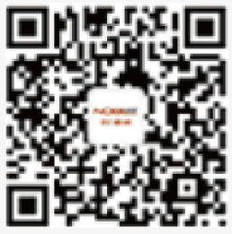

Scan QR Code for More

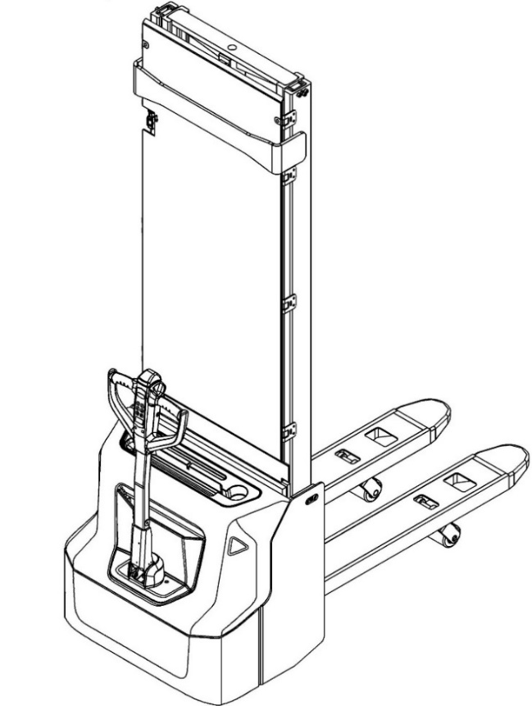

Electric Pallet Stacker PSE12BD/PSE12ND
PARTS MANUAL
562346020101

Version: V03
Truck Identification Number From:

Parts Manual PSE12BD/PSE12ND-PM03EN

Please order parts from authorized dealers of Noblelift Intelligent Equipment Co., LTD.
In order to avoid wrong delivery, all the orders for spare parts should specify the following items:
- Truck model, identification number and manufacture year.
- Orders for spare parts of mast, hydraulic transmission unit, steering axle, motor, etc. shall indicate the manufacture number of these parts.
- Codes for Noblelift spare parts are shown in the table of parts manual. Please also pay attention to the description of supply status, order quantity, etc. (check the number listed in "Mark" column of the parts manual).
"Mark" Column:
The unmarked indicates the parts are in short supply cycle.
Number 1: supply as package. Indicating these that parts are small parts and seal parts, which are supplied in package unit and in short supply cycle.
Number 2: supply with constraints. Indicating that these spare parts are not in stock and will be prepared for production after receiving the order from customers, which are in long supply cycle.
Number 3: phasing-out supply. Indicating that these parts will be replaced by new parts due to technical improvements and the current stock will not be available when these parts run out. Please check the description of technical improvements notice.
Number 4: supply as assembly. Indicating that these parts are assembly parts defined by manufacture process, which cannot be supplied as a single part.
Number 5: check other tables.
This parts manual is the property of Noblelift and can be shared under the confidential agreement only, Noblelift has the right to claim for compensation of any unauthorized use. Copy without permission is not allowed. Figures in the manual are not limited by the original design. Noblelift Intelligent Equipment Co., LTD reserves the right to improve the products for continuous technology progress.
TABLE OF CONTENTS
Chapter 1: Drive system 1
01 Drive unit (532246013501) 1
02 Drive assembly (532246013001) 3
03 Motor assembly (532246013002) 5
Chapter 2: Hydraulic system 7
01 Hydraulic unit (562346024001) 7
02 Pump unit (532246023501) 9
Chapter 3: Truck structure 11
01 Truck frame (562346021501) 11
02 Truck frame (562346021502) 13
03 Forks (562346038001) 15
04 Battery holder (532246012501) 17
05 Battery holder (lithium battery) (532246012502) 19
06 Control panel assembly (532246010001) 21
Chapter 4: Steering system, braking system and wheels 23
01 Tiller (562346011001) 23
02 Tiller head (562346011002) 25
02 Tiller head (562346011002) continuation 27
03 Load wheel (562346017001) 29
04 Side wheel (532246016501) 31
05 Manual steering (532246031201) 33
Chapter 5: Mast system 35
01 Two stage mast (562346044001) 35
01 Two stage mast (562346044001) continuation 37
01 Two stage mast (562346044001) continuation 39
02 Single mast (562346043001) 41
02 Single mast (562346043001) continuation 43
03 Pull rod assembly (562346044002) 45
Chapter 6: Electrical parts and wire harness 47
01 Wire harness (532246033001) 47
02 Wire harness (lithium battery) (532246033002) 49
03 Electrical control unit (562346033003) 51
04 Charger (532246036501) 53
Chapter 7: Special equipment 55
01 Load backrest (532246040501) 55
02 Load backrest (Single mast) (532246040502) 57
Chapter 8: Others 59
01 Labels and decals (EU) (562346047001) 59
02 Labels and decals (USA) (562346047002) 61
Appendix 63
01 Electrical circuit diagram (lead-acid battery) (562346045501) 63
02 Electrical circuit diagram (Lithium battery) (562346045502) 64
03 Hydraulic circuit diagram (562346045503) 65
04 Easy worn parts list 66

Chapter 1: Drive system

01 Drive unit (532246013501)
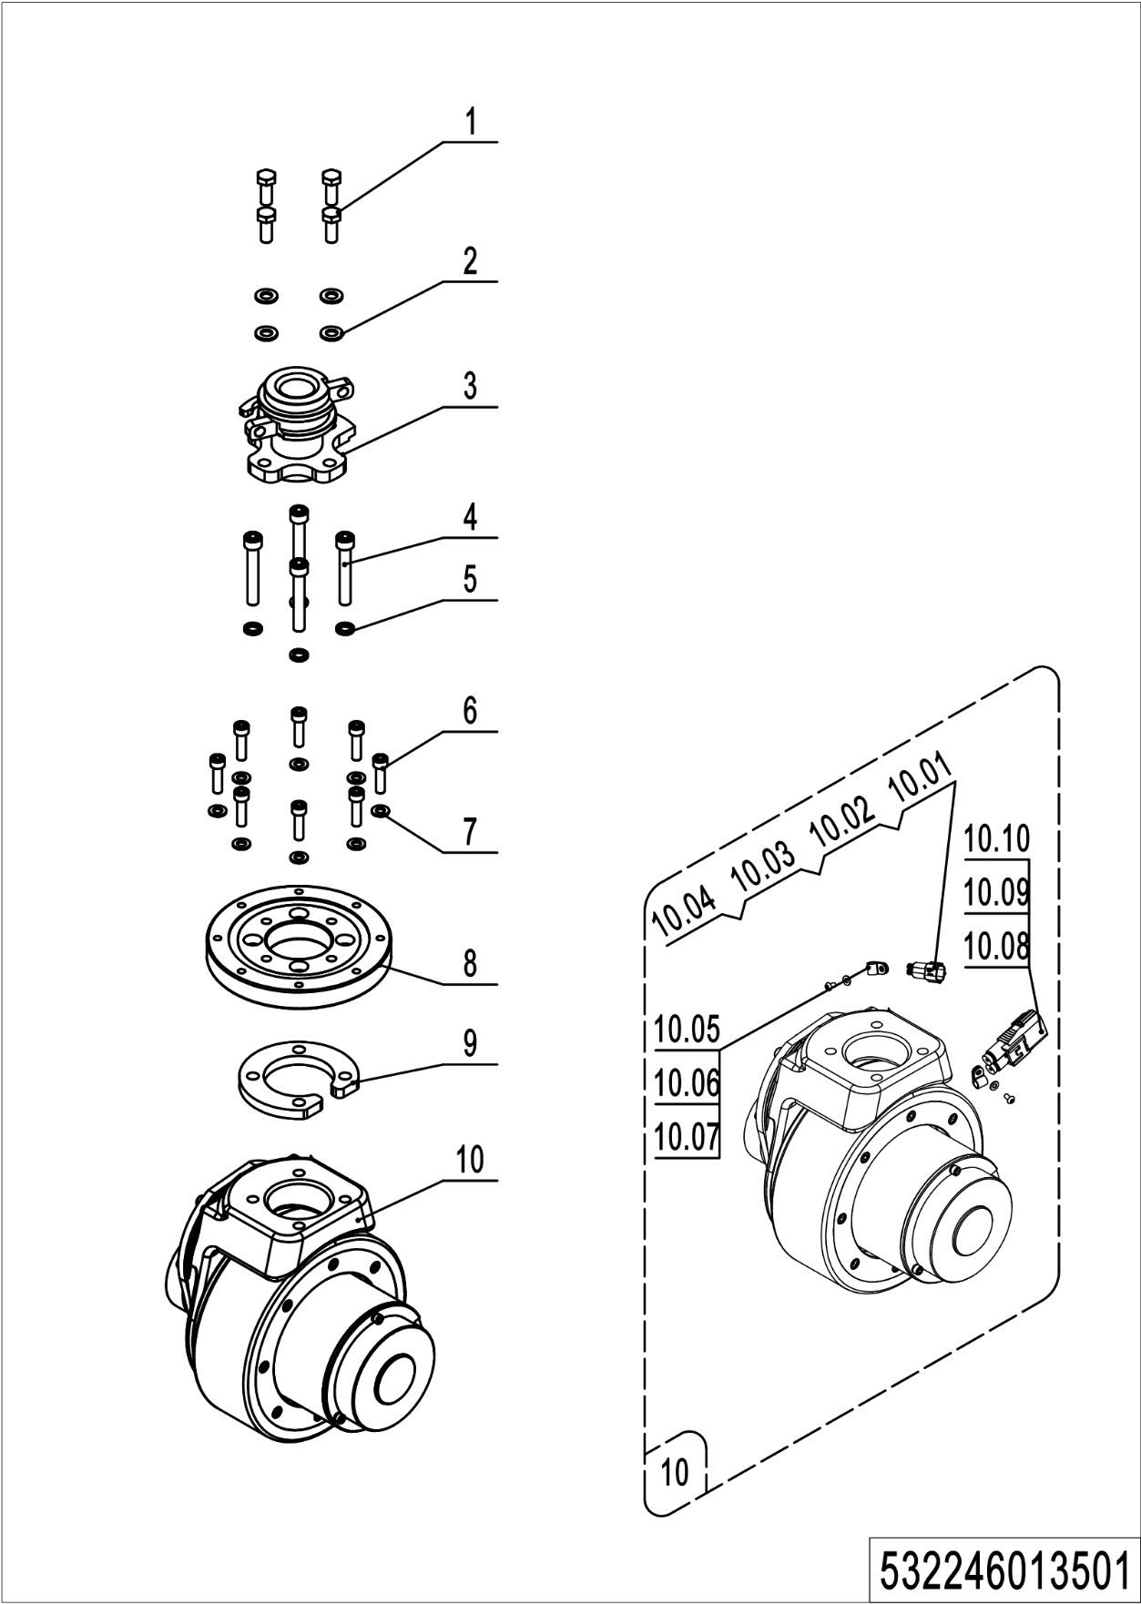
01 Drive unit (532246013501)
No. | Item Code | Mark | Item Description | Qty. | Substitute | Note
1 | 910100300036 | 1 | Bolt | 4
2 | 910400100007 | 1 | Flat Washer | 4
3 | 532231210005 |  | Drive Shaft | 1
4 | 910200200079 | 1 | Screw | 4
5 | 910400500007 | 1 | Spring Washer | 4
6 | 910200200138 | 1 | Screw | 8
7 | 910400100006 | 1 | Flat Washer | 8
8 | 532213520001 |  | Slewing Bearing | 1
9 | 532213520002 |  | Plate | 1
10 | 508098510078 | 5 | Drive Unit | 1 |  | PU wheel
 | 508098510079 | 5 | Drive Unit | 1 |  | Anti-skip wheel
10.01 | 920400200004 | 1 | Connector | 1
10.02 | 920400200003 | 1 | Connector | 1
10.03 | 920400200017 | 1 | Connector | 2
10.04 | 920400200018 | 1 | Connector | 2
10.05 | 910200700001 | 1 | Screw | 2
10.06 | 910400100003 | 1 | Flat Washer | 2
10.07 | 921300200001 |  | Cable Clamp | 2
10.08 | 920400200169 | 1 | Connector | 1
10.09 | 920400200150 | 1 | Connector | 2
10.10 | 920400200171 | 1 | Connector | 2

02 Drive assembly (532246013001)
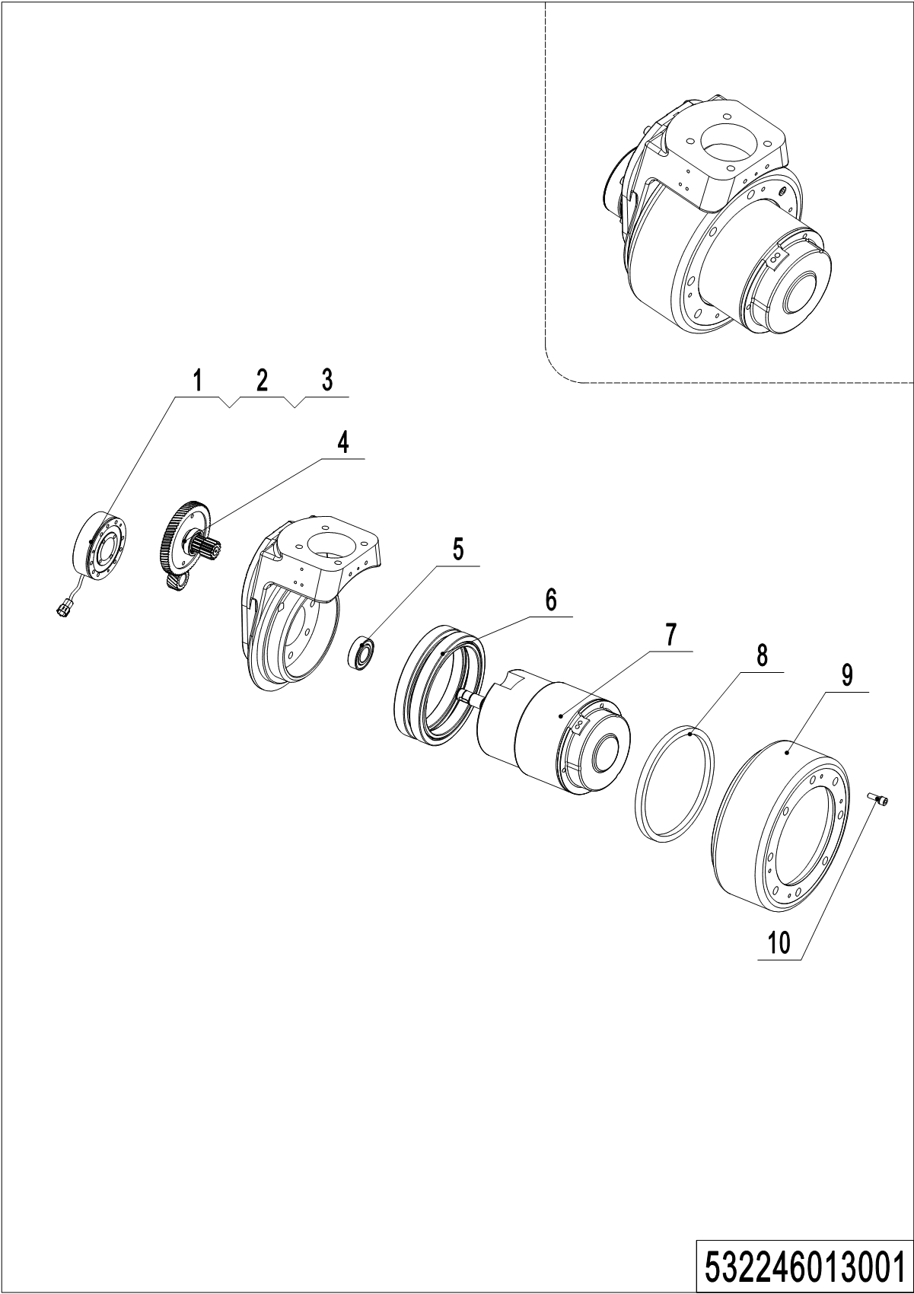
02 Drive assembly (532246013001)
No. | Item Code | Mark | Item Description | Qty. | Substitute | Note
-- | 508098510078 |  | Drive Unit | 1 |  | PU wheel
 | 508098510079 |  | Drive Unit | 1 |  | Anti-skip wheel
1 | 508098520002 | 2 | Brake | 1
2 | 508098520040 | 2 | Rubber Strip | 1
3 | 910200200019 | 1 | Screw | 3
4 | 508098510015 | 2 | Gear Components | 1
5 | 910700200004 | 2 | Bearing | 1
6 | 508098520011 | 2 | Gear Ring | 1
7 | 508098510016 | 5 | Motor | 1 |  | Check 532246013002
8 | 508098520032 | 2 | Seal | 1
9 | 508098520003 |  | Wheel | 1
 | 508098520026 |  | Wheel | 1
10 | 910200200167 | 1 | Screw Kits | 8

03 Motor assembly (532246013002)
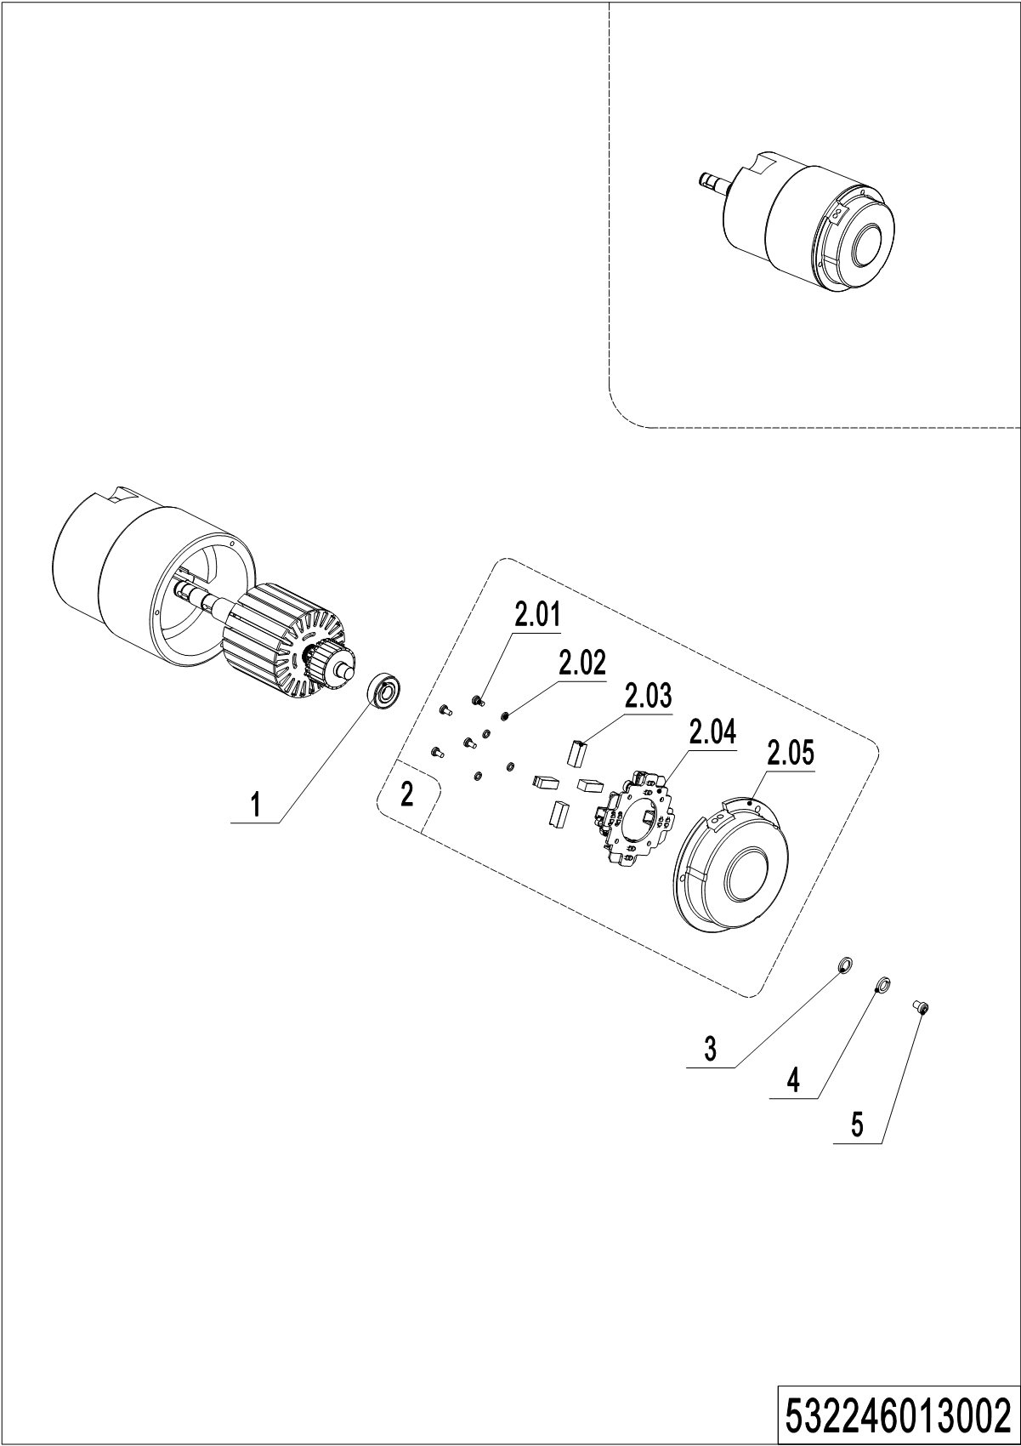
03 Motor assembly (532246013002)
No. | Item Code | Mark | Item Description | Qty. | Substitute | Note
-- | 508098510016 | 2 | Motor | 1
1 | 910700200016 | 2 | Bearing | 1
2 | 508098510074 | 2 | End Cap | 1
2.01 | 910200500034 | 1 | Screw | 4
2.02 | 910400500003 | 1 | Spring Washer | 4
2.03 | 508098520000 | 2 | Carbon Brush | 4
2.04 | 508098520001 | 2 | Carbon Brush Holder | 1
2.05 | 508098520036 | 2 | End Cap | 1
3 | 910400100002 | 1 | Flat Washer | 3
4 | 910400500002 | 1 | Spring Washer | 3
5 | 910200200023 | 1 | Screw | 3

Chapter 2: Hydraulic system

01 Hydraulic unit (562346024001)
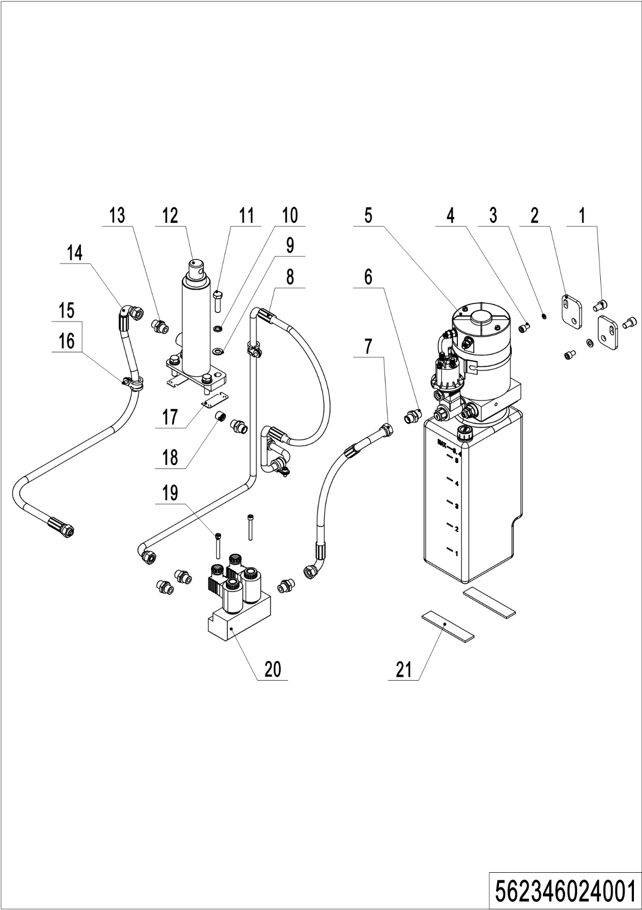
01 Hydraulic unit （562346024001)
No. | Item Code | Mark | Item Description | Qty. | Substitute | Note
1 | 910200200074 | 1 | Screw | 2
2 | 532223520001 |  | Plate | 2
3 | 910400100006 | 1 | Flat Washer | 2
4 | 910200200053 | 1 | Screw | 2
5 | ------------ | 5 | Pump Unit | 1 |  | Check 532246023501
6 | 950400300007 |  | Joint | 1
7 | 562324510005 |  | Hose | 1
8 | 562324510004 |  | Hose | 1
9 | 910400100007 | 1 | Flat Washer | 4
10 | 910400500007 | 1 | Spring Washer | 4
11 | 910100300038 | 1 | Bolt | 4
12 | 562324510001 |  | Cylinder | 1
13 | 950400400003 |  | Joint | 5
14 | 562324510003 |  | Hose | 1
15 | 910200200033 | 1 | Screw | 3
16 | 951000100003 |  | Hose Clamp | 3
17 | 562324520001 |  | Plate | 2
 | 562324520002 |  | Plate | 2
18 | 950600300001 |  | Safety Valve | 1
19 | 910200200043 | 1 | Screw | 2
20 | 562324510002 |  | Valve Block | 1
21 | 532223520010 |  | Crash Pad | 2

02 Pump unit (532246023501)
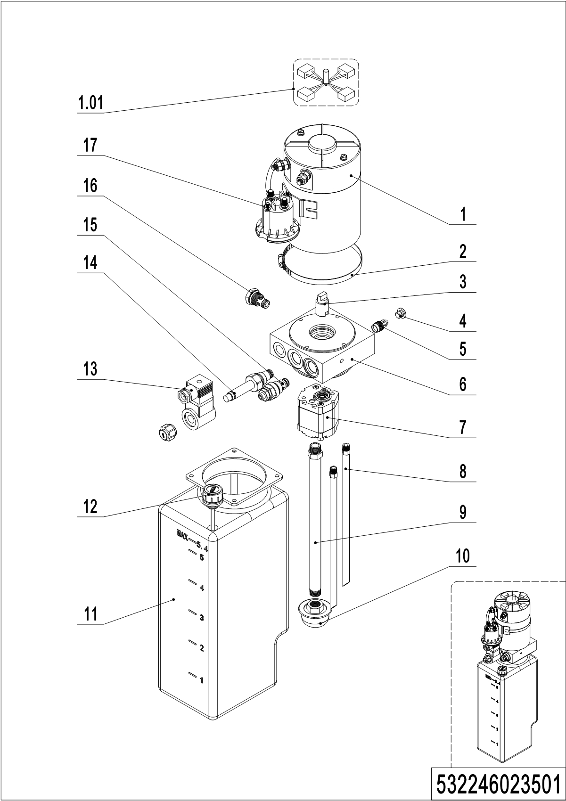
02 Pump unit （532246023501)
No. | Item Code | Mark | Item Description | Qty. | Substitute | Note
-- | 950900100069 |  | Pump Unit | 1
1 | 532298510037 |  | Motor | 1
1.01 | 532298510026 |  | Carbon Brush | 1
2 | 532298510040 |  | Hose Clamp | 1
3 | 532298520007 |  | Coupling | 1
4 | 532298520003 |  | End Cap | 1
5 | 532298510027 |  | Valve | 1
6 | 532298520006 |  | Valve Block | 1
7 | 532298510043 |  | Gear pump | 1
8 | 532298520004 |  | Pipe | 2
9 | 532298520005 |  | Oil Tube | 1
10 | 532298510031 |  | Filter | 1
11 | 532298510029 |  | Tank | 1
12 | 532298510030 |  | Cap-Tank | 1
13 | 532298510034 |  | Coil | 1
14 | 532298510033 |  | Magnetic Valve | 1
15 | 532298510044 |  | Overflow valve | 1
16 | 532298510028 |  | Check Valve | 1
17 | 532298510036 |  | Switch | 1

Chapter 3: Truck structure

01 Truck frame (562346021501)
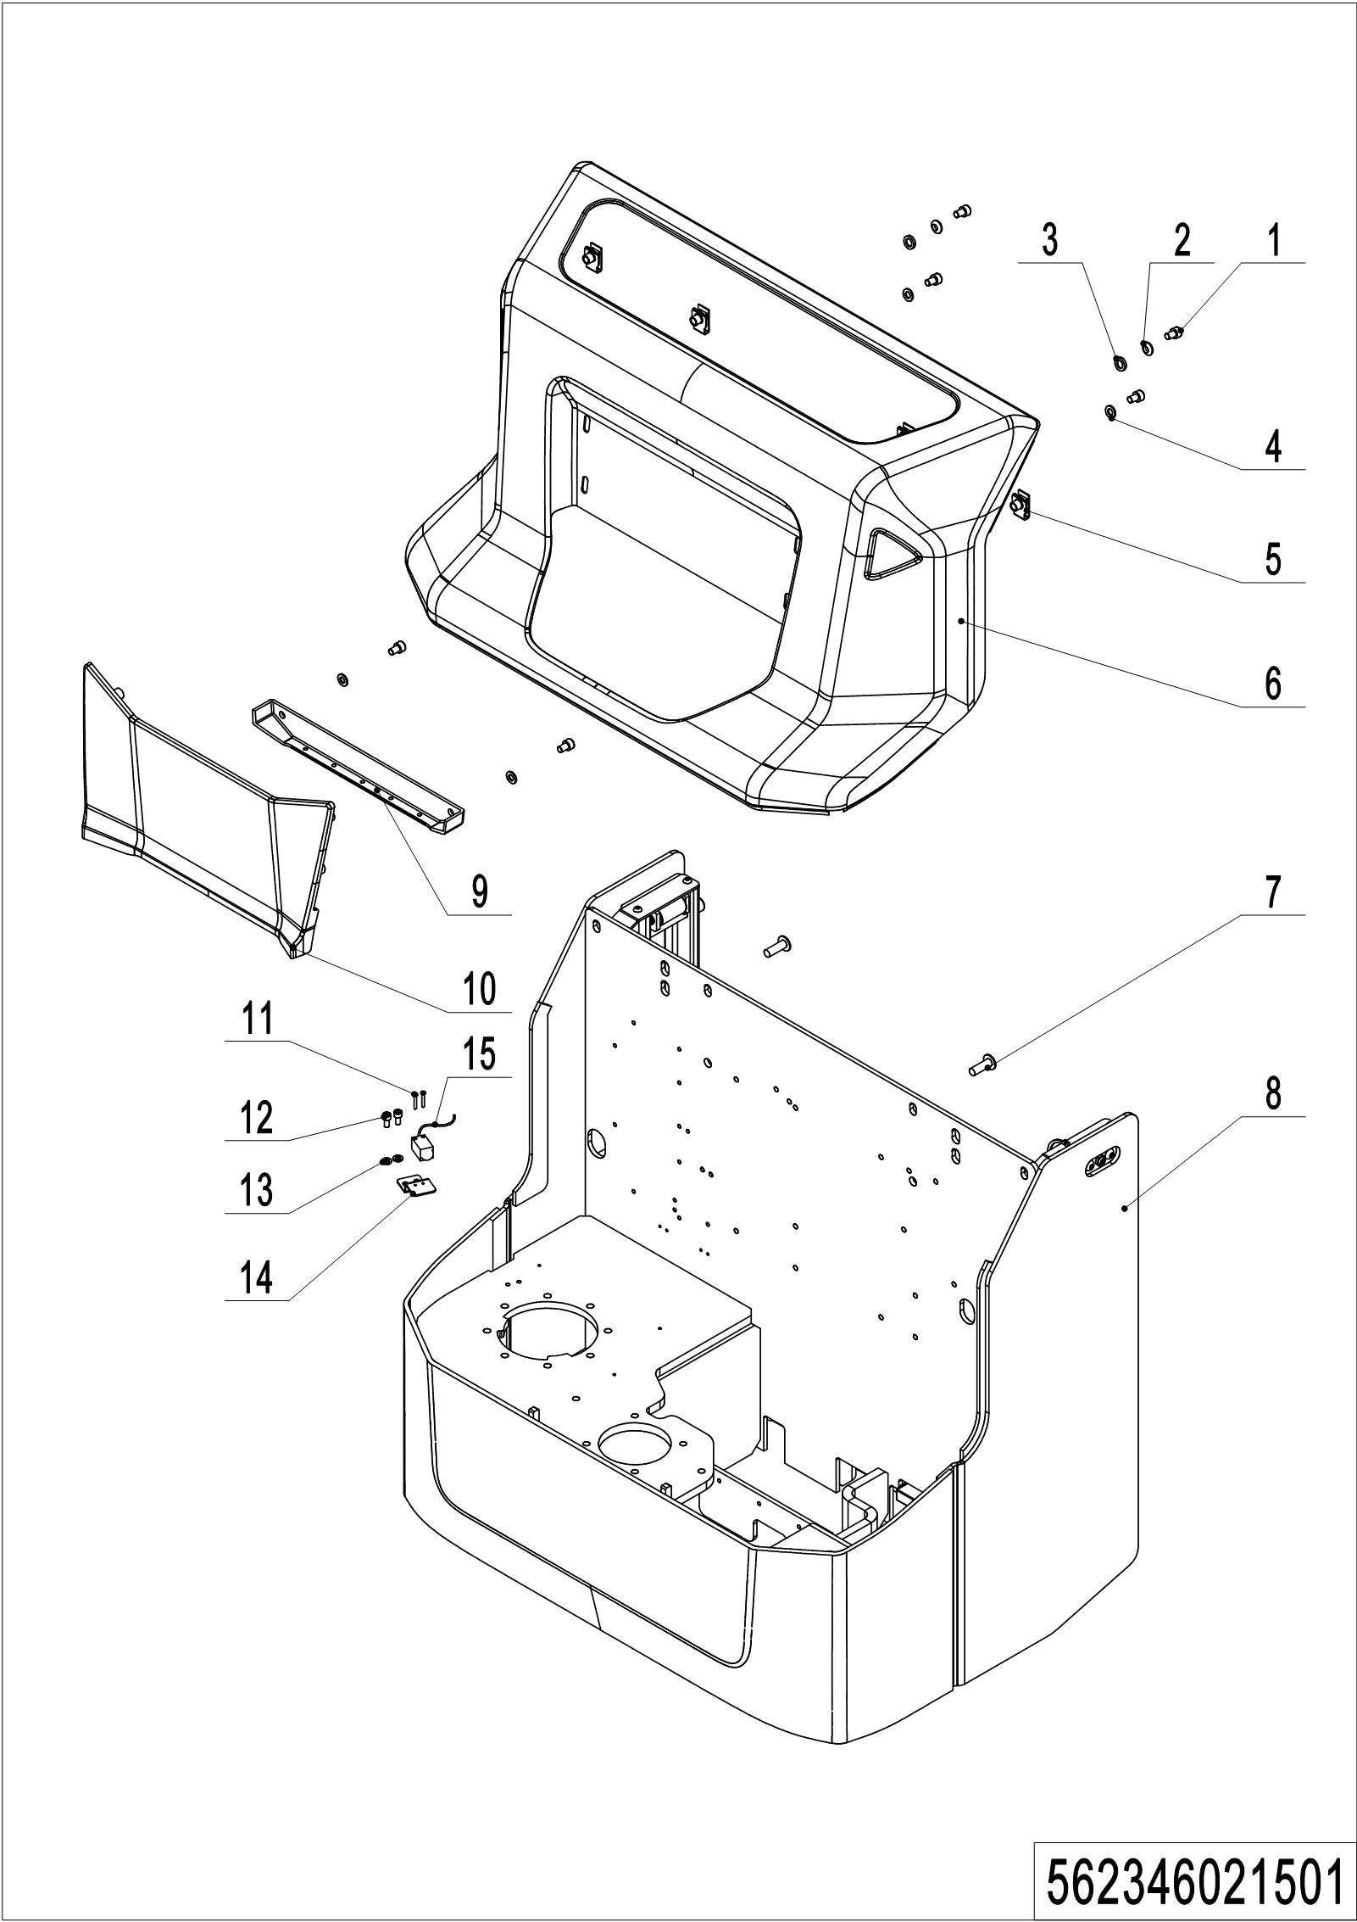
01 Truck frame (562346021501)
No. | Item Code | Mark | Item Description | Qty. | Substitute | Note
1 | 910200200053 | 1 | Screw | 6
2 | 910400600004 | 1 | Spherical Washer | 2
3 | 910400700004 | 1 | Cone Washer | 2
4 | 910400100006 | 1 | Flat Washer | 4
5 | 940400400003 |  | Cage Nut | 4
6 | 532221510003 |  | Cover | 1
7 | 941100100004 | 1 | Screw | 4
8 | 562321510001 | 2 | Chassis (570x1150) | 1 |  | 570x1150
 | 562321511001 | 2 | Chassis (685x1150) | 1 |  | 685x1150
9 | 532221520025 |  | Cover | 1
10 | 532221520024 |  | Panel | 1
11 | 910200500015 | 1 | Screw | 2
12 | 910200200033 | 1 | Screw | 2
13 | 910400100005 | 1 | Flat Washer | 2
14 | 532221520031 |  | Mounting Plate | 1

02 Truck frame (562346021502)
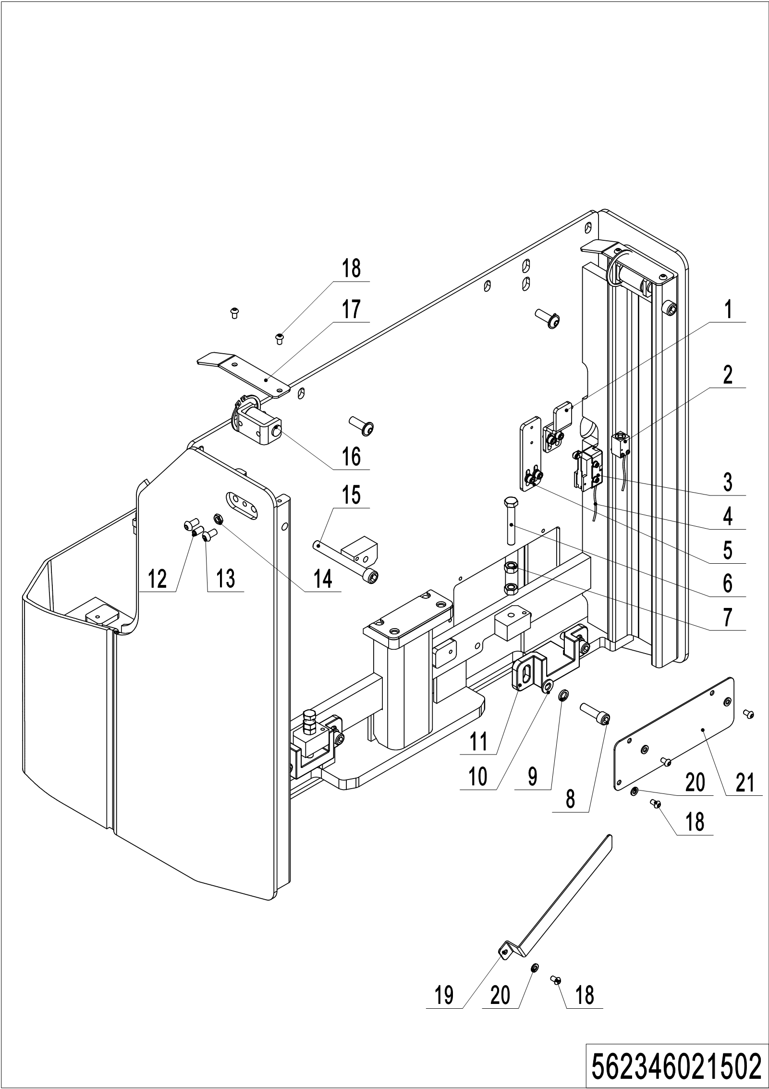
02 Truck frame (562346021502)
No. | Item Code | Mark | Item Description | Qty. | Substitute | Note
1 | 562321520003 |  | Plate | 1
2 | 505633510000 |  | Proximity Switch | 1
3 | 920200300003 |  | Microswitch | 1
4 | 562333010004 |  | Cable | 1
5 | 562321520002 |  | Plate | 1
6 | 910100300044 |  | Bolt | 2
7 | 910300100007 |  | Nut | 4
8 | 910200200077 |  | Screw | 4
9 | 910400500007 |  | Spring Washer | 4
10 | 910400100007 |  | Flat Washer | 4
11 | 562321520001 |  | Jacking block | 2
12 | 910200800020 |  | Screw | 2
13 | 910200300024 |  | Screw | 4
14 | 910300300004 |  | Nut | 2
15 | 910200200090 |  | Screw | 2
16 | 400244010002 |  | Roller | 2
17 | 562321520004 |  | Plate | 2
18 | 910200300016 |  | Screw | 6
19 | 562321520005 |  | Plate | 1
20 | 910400100005 |  | Flat Washer | 4
21 | 562321520116 |  | Plate | 1

03 Forks (562346038001)
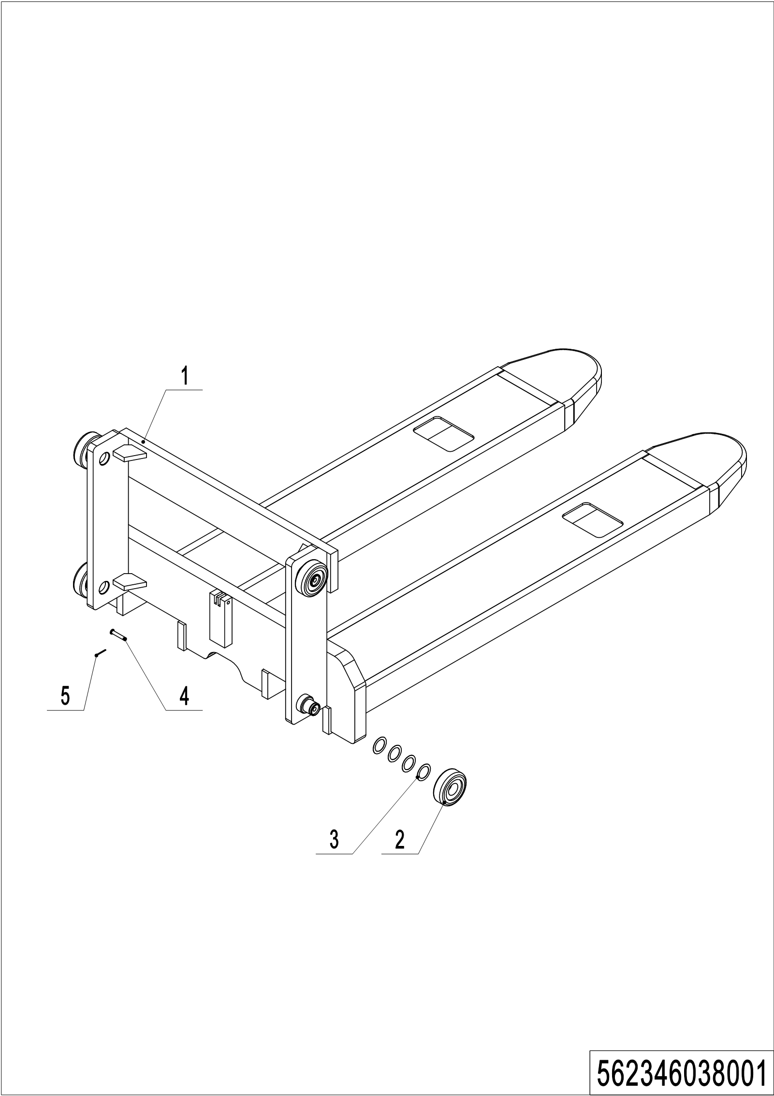
03 Forks (562346038001)
No. | Item Code | Mark | Item Description | Qty. | Substitute | Note
1 | 562338010001 | 2 | Fork(570x1150) | 1 |  | Two-stage mast
 | 562338010002 | 2 | Fork(685x1150) | 1 |  | Two-stage mast
 | 562338010003 | 2 | Fork(570x1150) | 1 |  | Single mast
 | 562338010004 | 2 | Fork(685x1150) | 1 |  | Single mast
2 | 940200100038 |  | Main Roller | 4
3 | 940600500016 |  | Washer | 24 |  | on demand
4 | 941100800006 | 1 | Pin | 1
5 | 910600600015 | 1 | Cotter Pin | 1

04 Battery holder (532246012501)
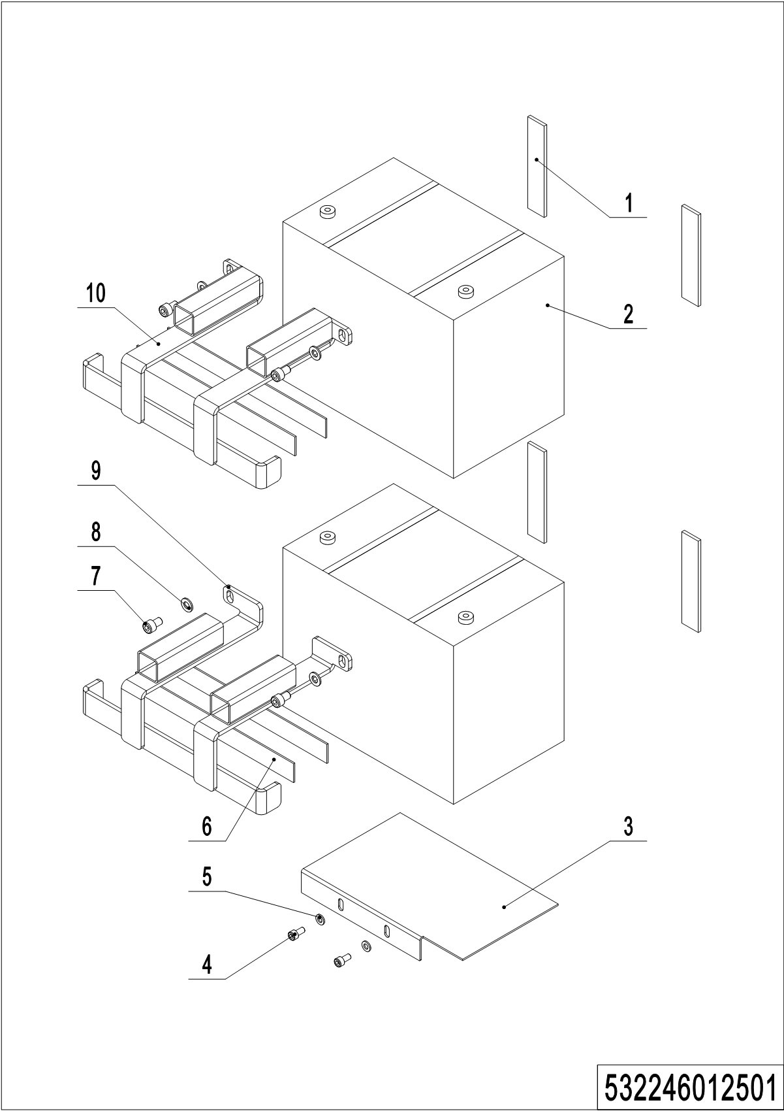
04 Battery holder (532246012501)
No. | Item Code | Mark | Item Description | Qty. | Substitute | Note
1 | 532223520010 |  | Crash Pad | 4
2 | 920600100105 |  | Battery12V85Ah | 2 |  | TN
 | 920600100107 |  | Battery12V106Ah | 2 |  | TN
3 | 532212520006 |  | Mounting Plate | 1
4 | 910200200033 | 1 | Screw | 2
5 | 910400100005 | 1 | Flat Washer | 2
6 | 532233020005 |  | Crash Pad | 4 |  | 85Ah
7 | 910200200053 | 1 | Screw | 4
8 | 910400100006 | 1 | Flat Washer | 4
9 | 532212510002 |  | Mounting Plate | 1 |  | 85Ah
 | 532212510004 |  | Mounting Plate | 1 |  | 106Ah
10 | 532212510001 |  | Mounting Plate | 1 |  | 85Ah
 | 532212510003 |  | Mounting Plate | 1 |  | 106Ah

05 Battery holder (lithium battery) (532246012502)
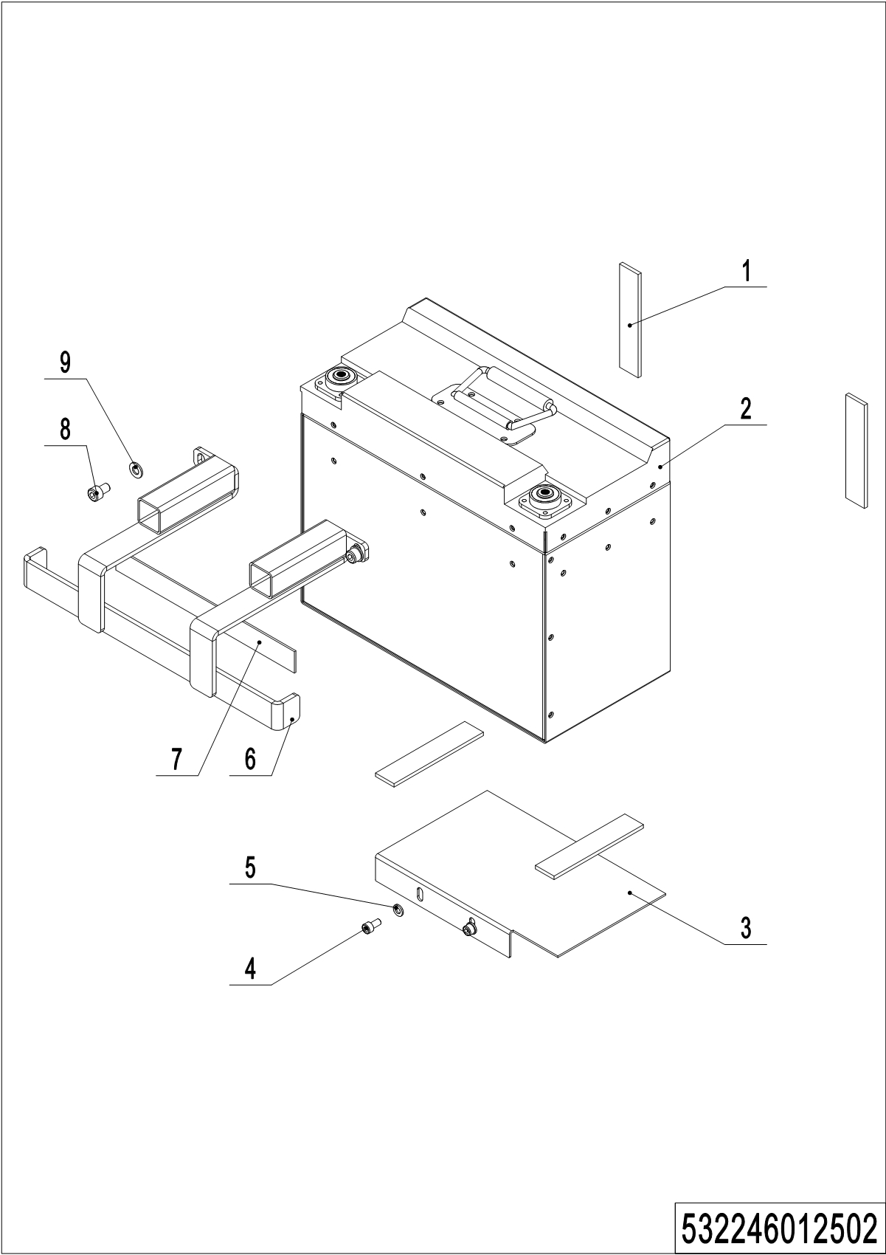
05 Battery holder (lithium battery) (532246012502)
No. | Item Code | Mark | Item Description | Qty. | Substitute | Note
1 | 532223520010 |  | Crash Pad | 4
2 | 920600100082 |  | Li Battery24V60Ah | 1 |  | HF
3 | 532212520006 |  | Mounting Plate | 1
4 | 910200200033 | 1 | Screw | 2
5 | 910400100005 | 1 | Flat Washer | 2
6 | 532212510003 |  | Mounting Plate | 1
7 | 532233020005 |  | Crash Pad | 1
8 | 910200200053 | 1 | Screw | 2
9 | 910400100006 | 1 | Flat Washer | 2

06 Control panel assembly (532246010001)
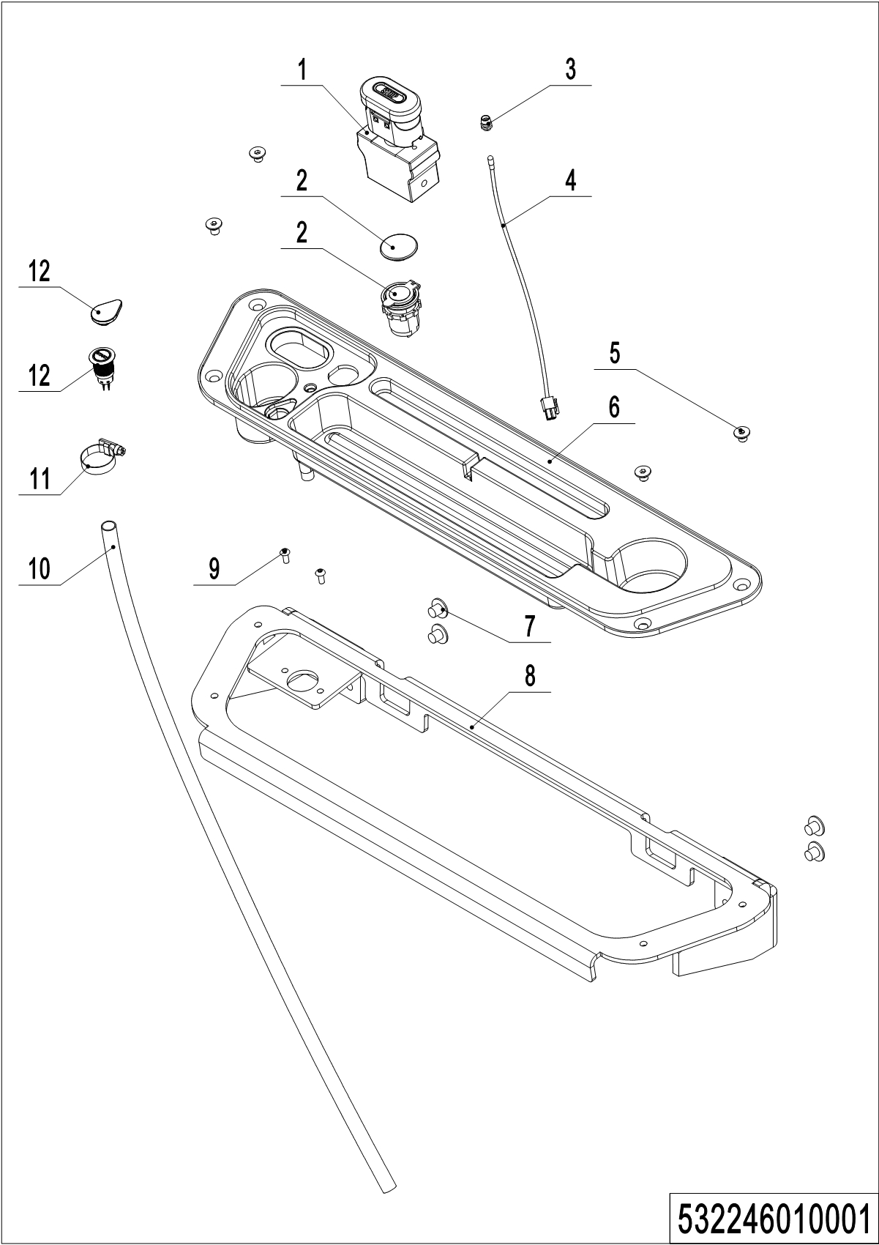
06 Control panel assembly (532246010001)
No. | Item Code | Mark | Item Description | Qty. | Substitute | Note
1 | 920200100009 |  | Emergency Button | 1
2 | 532210020003 |  | Close Plate | 1 |  | Lead-acid battery
 | 206033010036 |  | USB interface | 1 |  | Lithium battery
3 | 922000100024 |  | Lamp Holder | 1
4 | 532298510006 |  | Indicator Light | 1
5 | 910200400023 | 1 | Screw | 4
6 | 532210020001 |  | Bezel | 1
7 | 941100100005 |  | Screw | 4
8 | 532210010001 |  | Mounting Plate | 1
9 | 910200300012 | 1 | Screw | 2
10 | 532210020008 |  | Pipe | 1
11 | 911000600008 |  | Hose Clamp | 1
12 | 532210020002 |  | Close Plate | 1 |  | Lead-acid battery
 | 532233010023 |  | Button | 1 |  | Lithium battery

Chapter 4: Steering system, braking system and wheels

01 Tiller (562346011001)
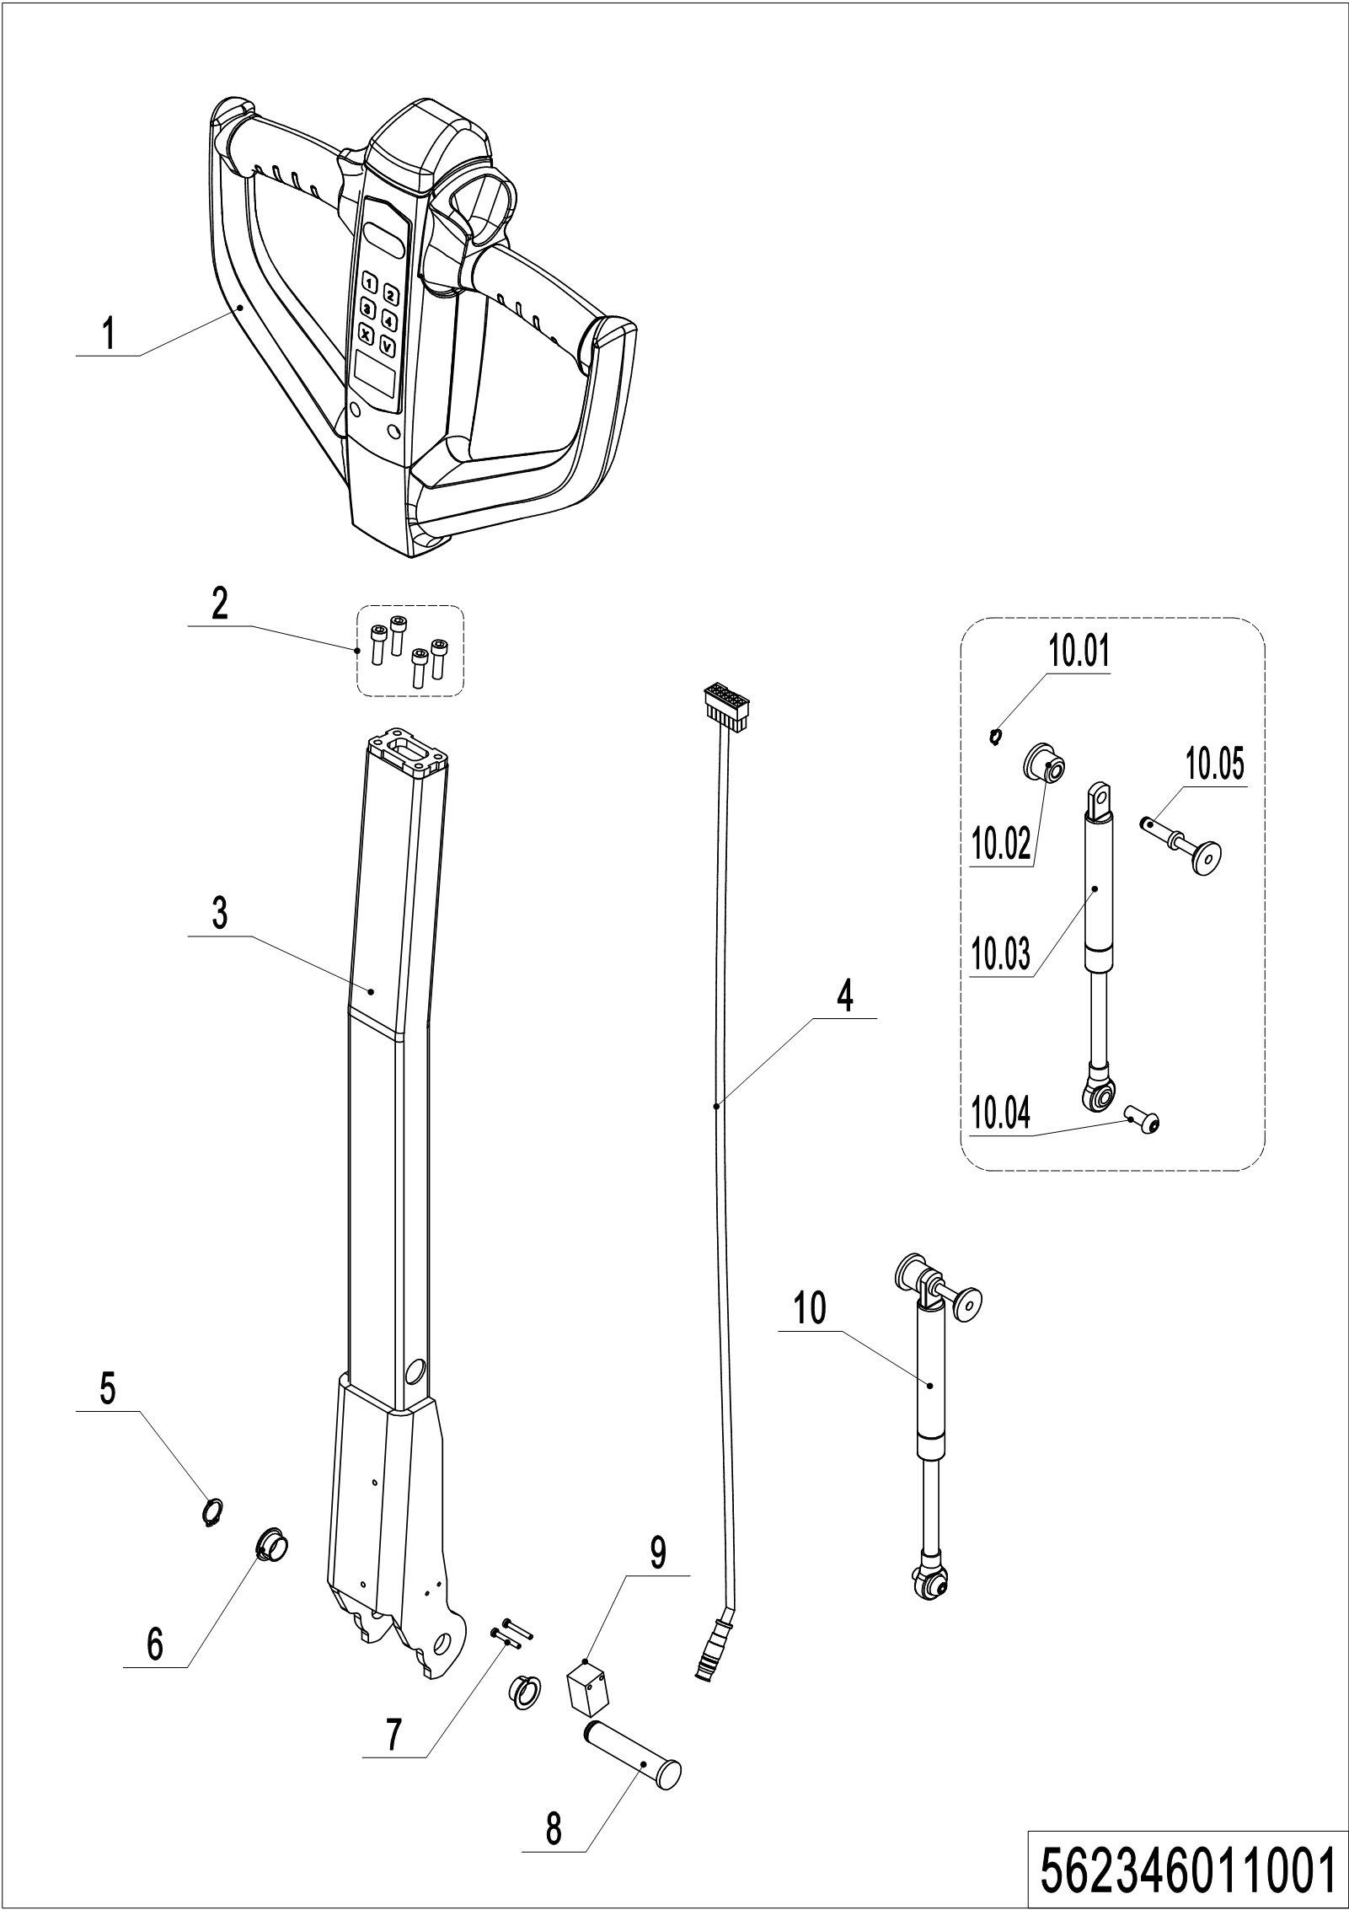
01 Tiller （562346011001）
No. | Item Code | Mark | Item Description | Qty. | Substitute | Note
1 | 562311010001 |  | Tiller | 1
 | 562311010002 |  | Tiller | 1 |  | IC card
2 | 910200200036 | 1 | Screw | 4
3 | 532211010000 |  | Tiller | 1
4 | 532233010019 |  | Wire Harness | 1
5 | 910401300006 |  | Circlip | 1
6 | 940500200001 |  | Bushing | 2
7 | 941101100001 | 1 | Screw | 2
8 | 508011020004 |  | Pin | 1
9 | 505633510001 |  | Proximity Switch | 1
10 | 532298510039 |  | Air spring kits | 1
10.1 | 910401300001 |  | Circlip | 1
10.2 | 508011020005 |  | Fixing Base | 1
10.3 | 532211020003 |  | Gas Spring | 1
10.4 | 941100100011 | 1 | Screw | 1
10.5 | 508011010002 |  | Pin | 1

02 Tiller head (562346011002)
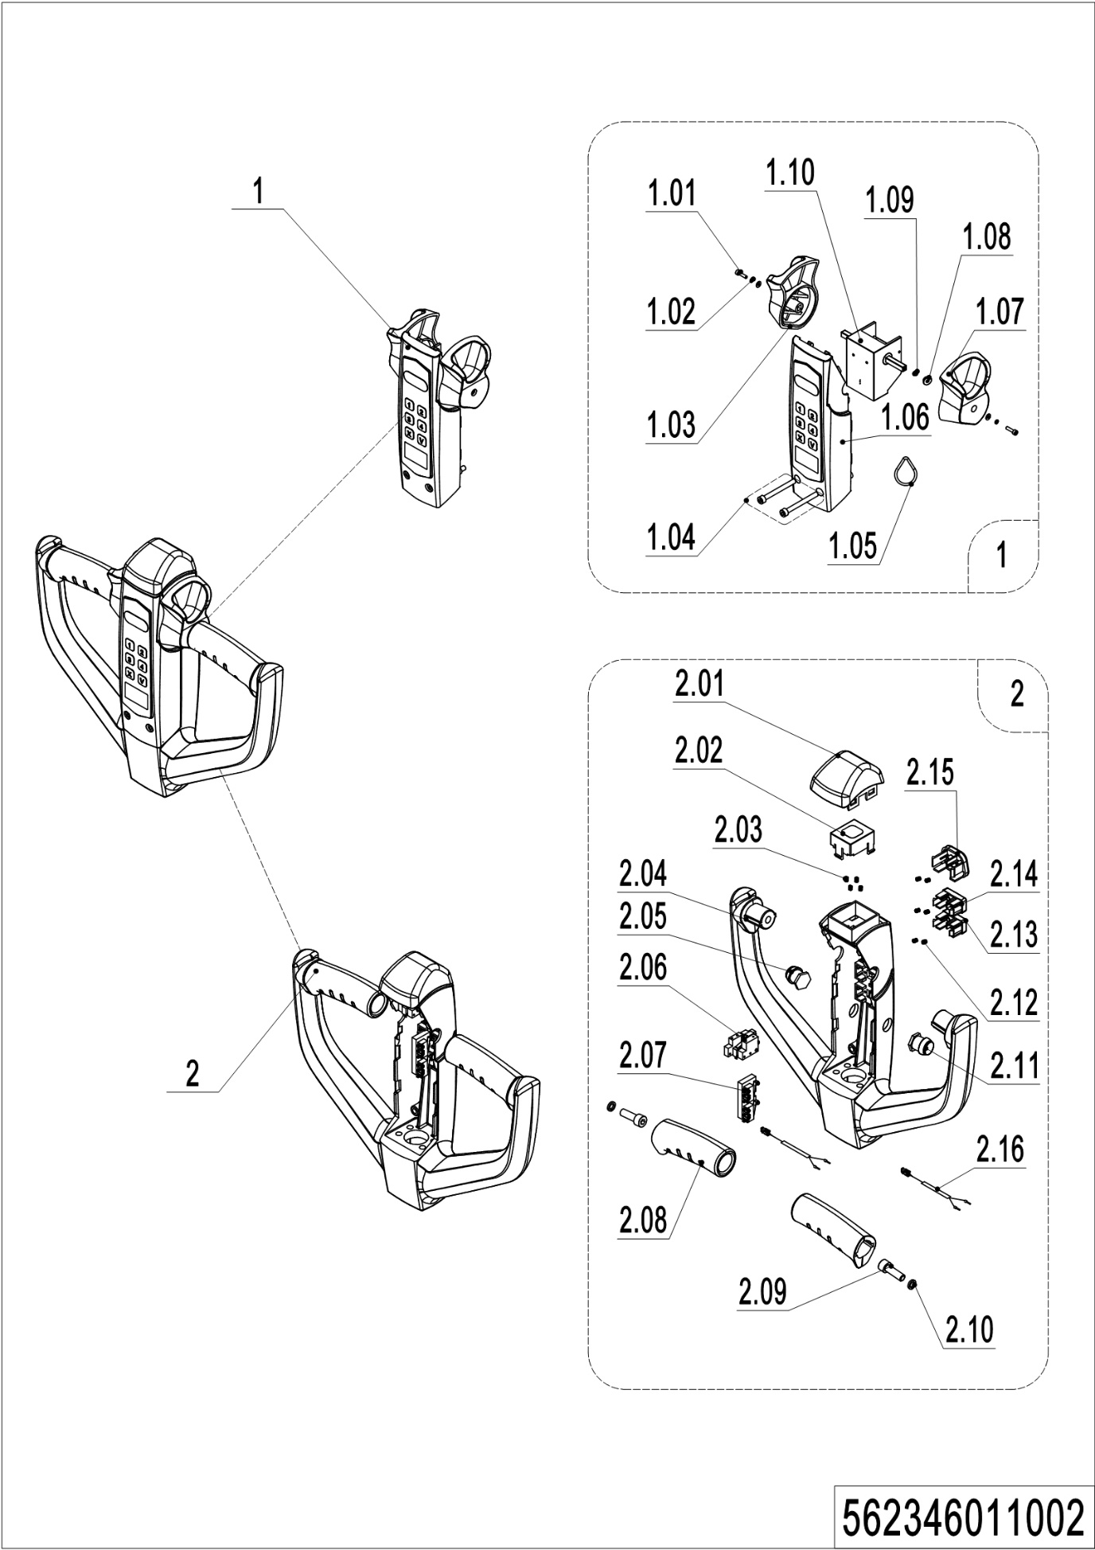
02 Tiller head （562346011002）
No. | Item Code | Mark | Item Description | Qty. | Substitute | Note
1 | 532298510022 |  | Handle Cap Kit | 1
 | 532298510023 |  | Handle Cap Kit | 1 |  | IC card
1.01 | 910200200003 | 1 | Screw | 2
1.02 | 910400500002 | 1 | Spring Washer | 2
1.03 | 508098520014 |  | Traction lever | 1
1.04 | 910200200159 | 1 | Screw | 2
1.05 | 508098520027 |  | ID Card | 1 |  | With RFID card function
1.06 | 532298510054 |  | Display Screen kit | 1
 | 532298510055 |  | Display Screen kit | 1 |  | IC card
1.07 | 508098520020 |  | Traction lever | 1
1.08 | 508098520015 |  | Bushing | 2
1.09 | 508098520016 |  | Bushing | 2
1.10 | 532298510005 |  | Accelerator | 1
 | 532298510007 |  | Accelerator | 1 |  | IC card
2 | 562398510002 |  | Handle Cap Kit | 1
2.01 | 508098520018 |  | Cap,Break Switch | 1
2.02 | 508098520019 |  | Bracket | 1
2.03 | 502311020018 |  | Spring | 4
2.04 | 562398520002 |  | Handle Cap | 1
2.05 | 920200700021 |  | Switch | 1
2.06 | 508098510029 |  | Microswitch Kits | 1
2.07 | 508098510030 |  | Microswitch Kits | 1
2.08 | 508098520013 |  | Handle | 2
2.09 | 910200200058 | 1 | Screw | 2
2.10 | 910400500006 | 1 | Spring Washer | 2
2.11 | 920200700022 |  | Switch | 1
2.12 | 502311020022 |  | Spring | 6
2.13 | 508098520031 |  | Button | 1

02 Tiller head (562346011002) continuation
02 Tiller head (562346011002) continuation
No. | Item Code | Mark | Item Description | Qty. | Substitute | Note
2.14 | 508098520030 |  | Button | 1
2.15 | 508098520029 |  | Horn Button | 1
2.16 | 562333010005 |  | Cable | 2

03 Load wheel (562346017001)
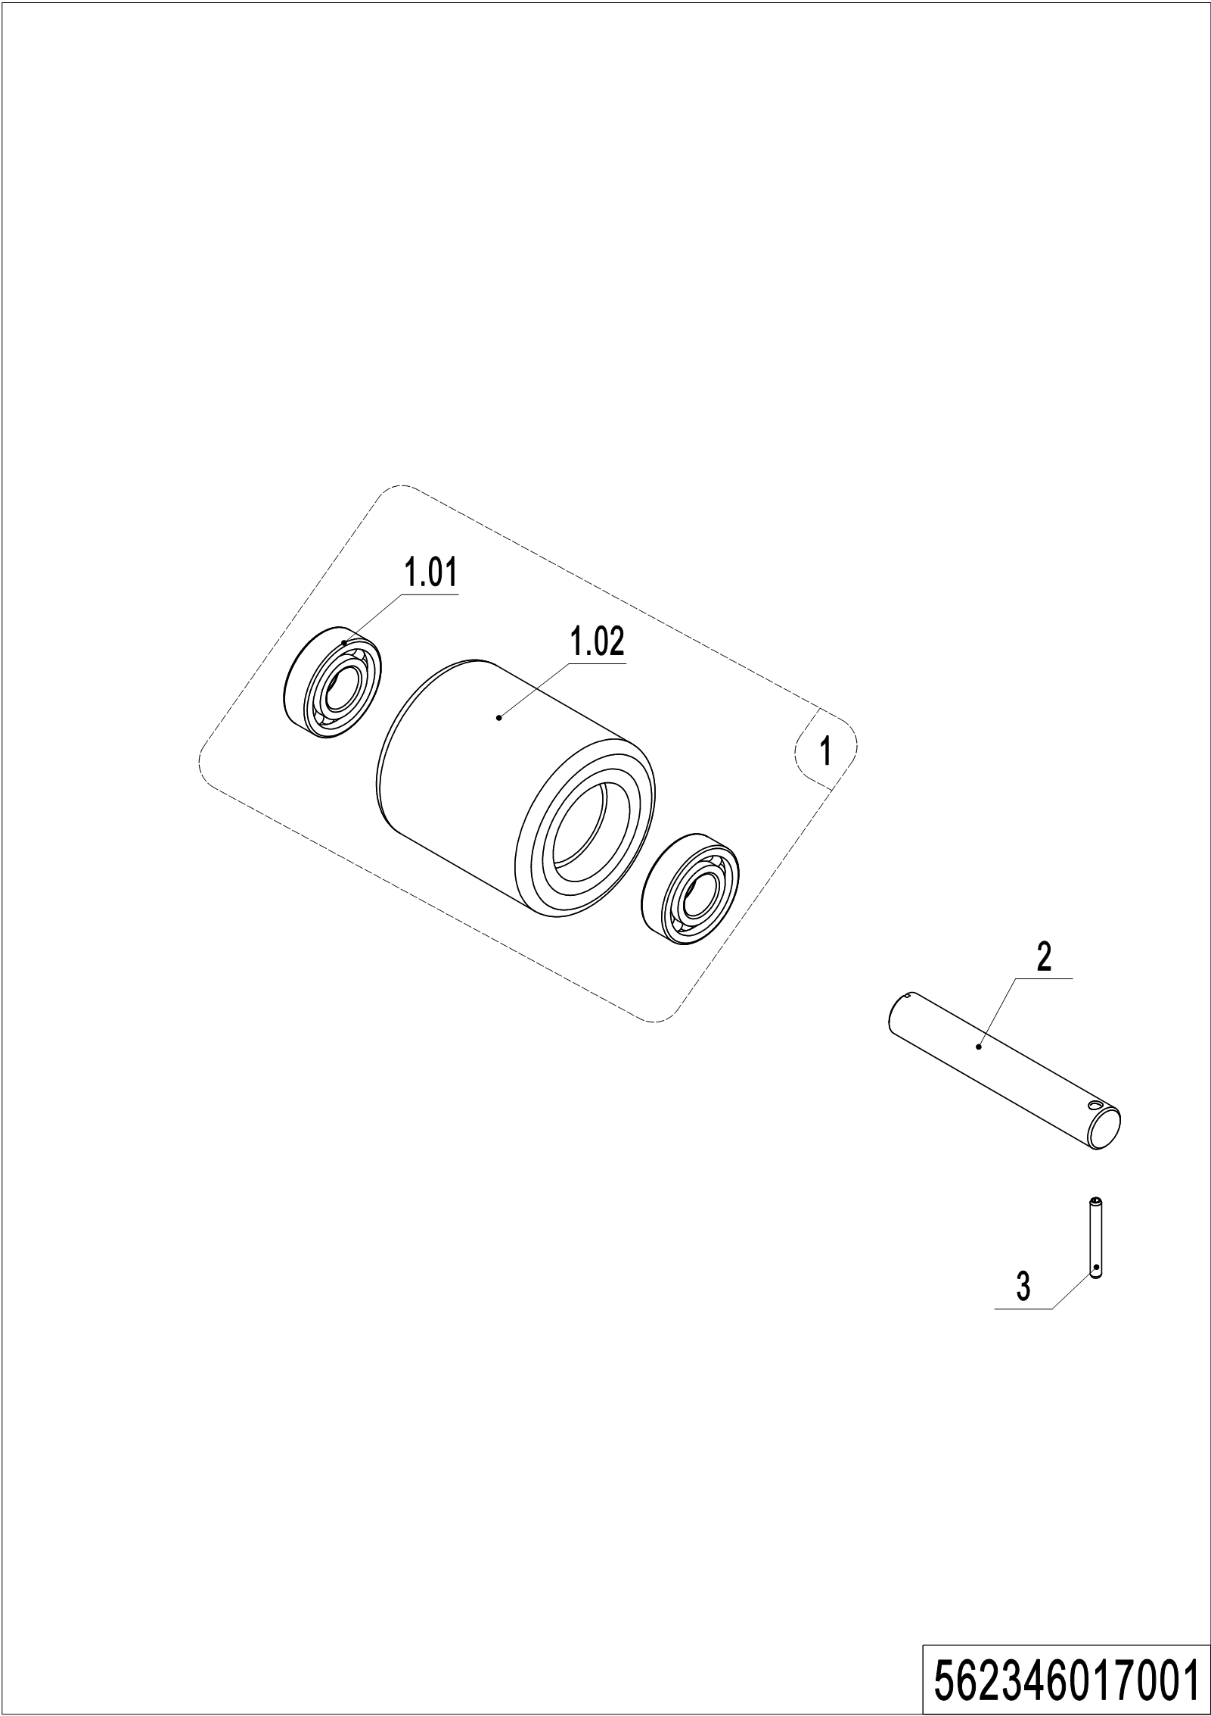
03 Load wheel (562346017001)
No. | Item Code | Mark | Item Description | Qty. | Substitute | Note
1 | 532298510003 |  | Wheel | 2
1.01 | 910700200019 |  | Bearing | 4
1.02 | 940300300011 |  | WheelΦ84x93 | 2
2 | 532217020001 |  | Axle | 2
3 | 910600400019 |  | Spring Pin | 2

04 Side wheel (532246016501)
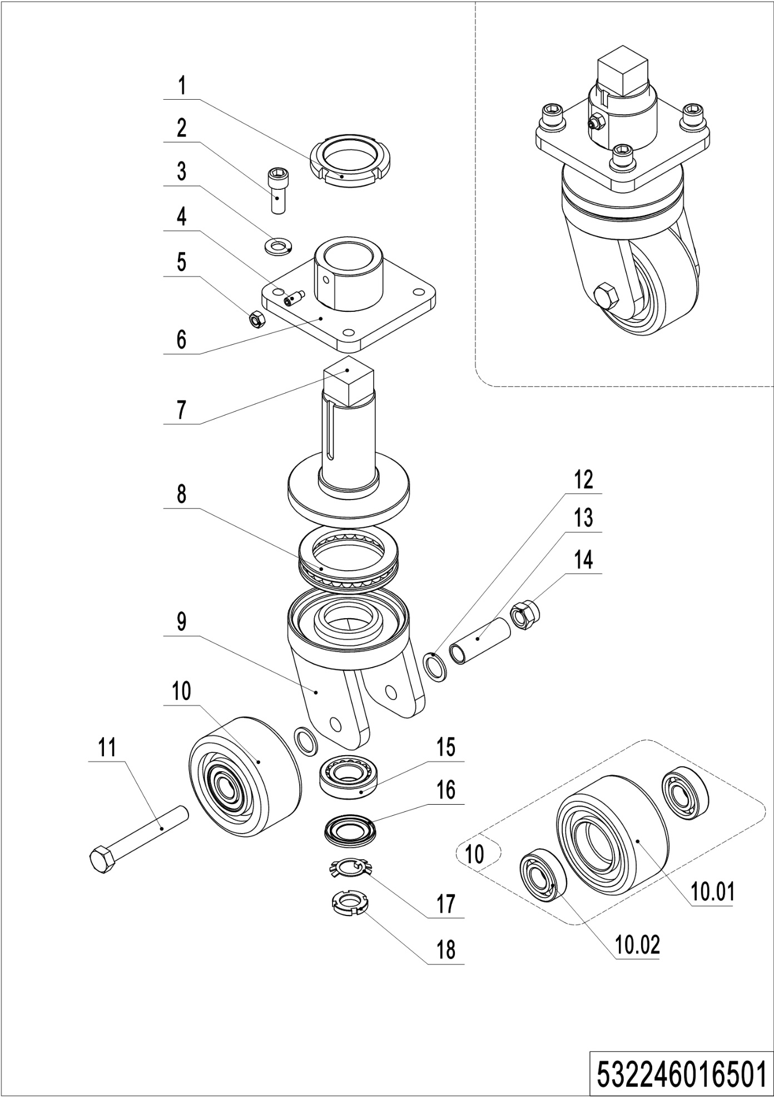
04 Side wheel (532246016501)
No. | Item Code | Mark | Item Description | Qty. | Substitute | Note
-- | 532298510041 |  | Caster Assembly | 1
1 | 941100900004 | 1 | Nut | 1
2 | 910200200098 | 1 | Screw | 4
3 | 910400100008 | 1 | Flat Washer | 4
4 | 910201000012 | 1 | Screw | 1
5 | 910300100006 | 1 | Nut | 1
6 | 532216510003 | 2 | Fixing Base | 1
7 | 532216510002 | 2 | Axle | 1
8 | 910700700011 |  | Bearing | 1
9 | 532216510001 | 2 | Wheel Carrier | 1
10 | 532298510004 |  | Caster Assembly | 1
10.01 | 940300300030 |  | WheelΦ100x50 | 1
10.02 | 910700200019 |  | Bearing | 2
11 | 910100100069 | 1 | Bolt | 1
12 | 940600500005 | 1 | Washer | 4
13 | 532216520006 |  | Sleeve | 1
14 | 910300500007 | 1 | Nut | 1
15 | 910700600001 |  | Bearing | 1
16 | 941101000010 |  | Cover | 1
17 | 910400900002 | 1 | Lock Washer | 1
18 | 910300700008 | 1 | Nut | 1

05 Manual steering (532246031201)
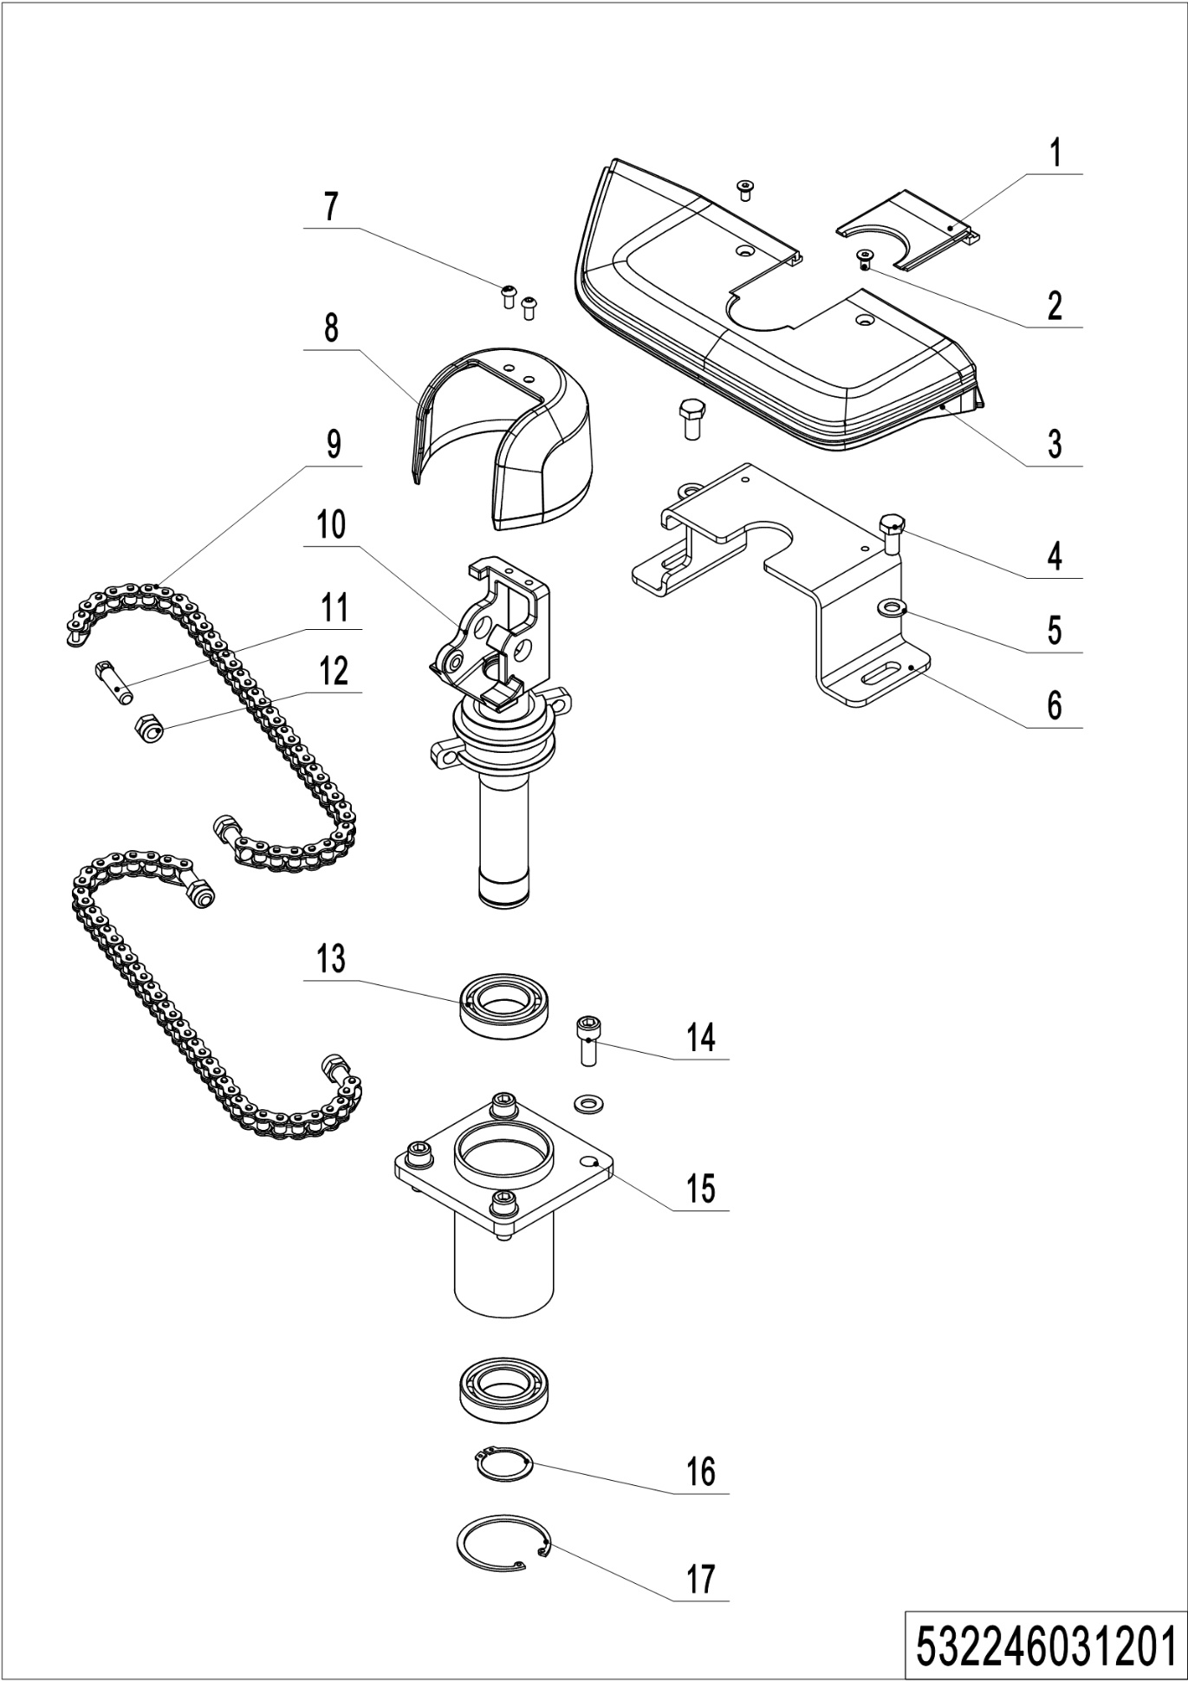
05 Manual steering （532246031201）
No. | Item Code | Mark | Item Description | Qty. | Substitute | Note
1 | 532231220011 |  | Handle Cap | 1
2 | 910200400016 | 1 | Screw | 2
3 | 532231220010 |  | Handle Cap | 1
4 | 910100300036 | 1 | Bolt | 2
5 | 910400100007 | 1 | Flat Washer | 6
6 | 532231220008 |  | Pedestal | 1
7 | 910200300017 | 1 | Screw | 2
8 | 532211020001 |  | Protective Cover | 1
9 | 532231210007 |  | Chain | 2
10 | 532231210006 |  | handle Spindle | 1
11 | 532231220018 |  | Bolt
12 | 910300500005 |  | Nut
13 | 910700200007 |  | Bearing | 2
14 | 910200200076 | 1 | Screw | 4
15 | 532231210003 |  | Bracket | 1
16 | 910401300018 | 1 | Circlip | 1
17 | 910401400018 | 1 | Circlip | 1

Chapter 5: Mast system

01 Two stage mast (562346044001)
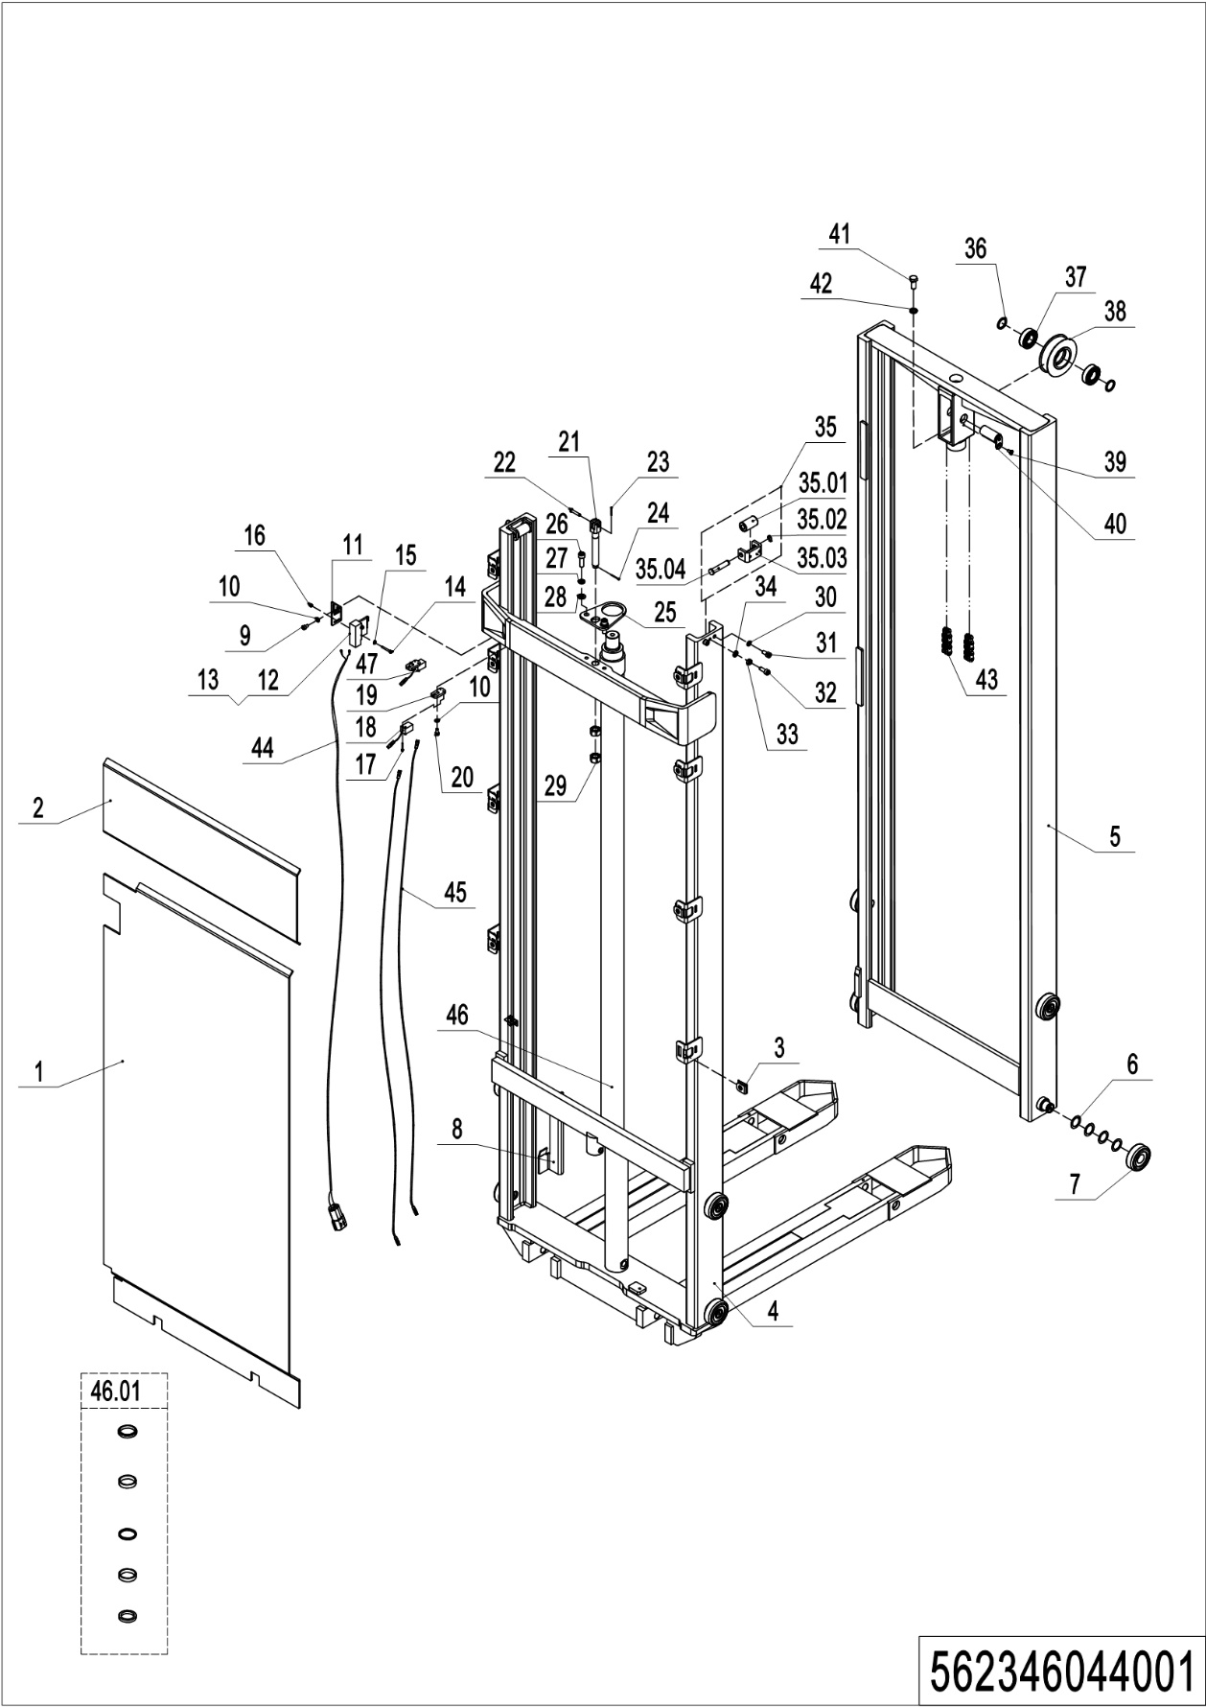
01 Two stage mast (562346044001)
No. | Item Code | Mark | Item Description | Qty. | Substitute | Note
1 | 562344020010 |  | Guard Plate | 1 |  | 2600
 | 562344020009 |  | Guard Plate | 1 |  | 2900
 | 562344020008 |  | Guard Plate | 1 |  | 3200
 | 562344020002 |  | Guard Plate | 1 |  | 3600
2 | 562344020003 |  | Guard Plate | 1
3 | 940400300001 |  | Spring Buckle | 8
4 | 562344013001 | 2 | Outer Mast (2600,570x1150) | 1 |  | 2600,570x1150
 | 562344013002 | 2 | Outer Mast (2600,685x1150) | 1 |  | 2600,685x1150
 | 562344012001 | 2 | Outer Mast (2900,570x1150) | 1 |  | 2900,570x1150
 | 562344012002 | 2 | Outer Mast (2900,685x1150) | 1 |  | 2900,685x1150
 | 562344011001 | 2 | Outer Mast (3200,570x1150) | 1 |  | 3200,570x1150
 | 562344011002 | 2 | Outer Mast (3200,685x1150) | 1 |  | 3200,685x1150
 | 562344010001 | 2 | Outer Mast (3600,570x1150) | 1 |  | 3600,570x1150
 | 562344010002 | 2 | Outer Mast (3600,685x1150) | 1 |  | 3600,685x1150
5 | 562344013003 | 2 | Inner Mast (2600) | 1 |  | 2600
 | 562344012005 | 2 | Inner Mast (2900) | 1 |  | 2900
 | 562344011005 | 2 | Inner Mast (3200) | 1 |  | 3200
 | 562344010005 | 2 | Inner Mast (3600) | 1 |  | 3600
6 | 940600500016 |  | Washer | 48
7 | 940200100038 |  | Main Roller | 8
8 | 562344020005 |  | Plate | 1
9 | 910200200032 | 1 | Screw | 2
10 | 910400100005 | 1 | Flat Washer | 6
11 | 562344020007 |  | Plate | 1
12 | 920200300003 |  | Microswitch | 1
13 | 920200300007 |  | Protective Cover | 1
14 | 910200500028 | 1 | Screw | 2
15 | 910400100003 | 1 | Flat Washer | 2

01 Two stage mast (562346044001) continuation
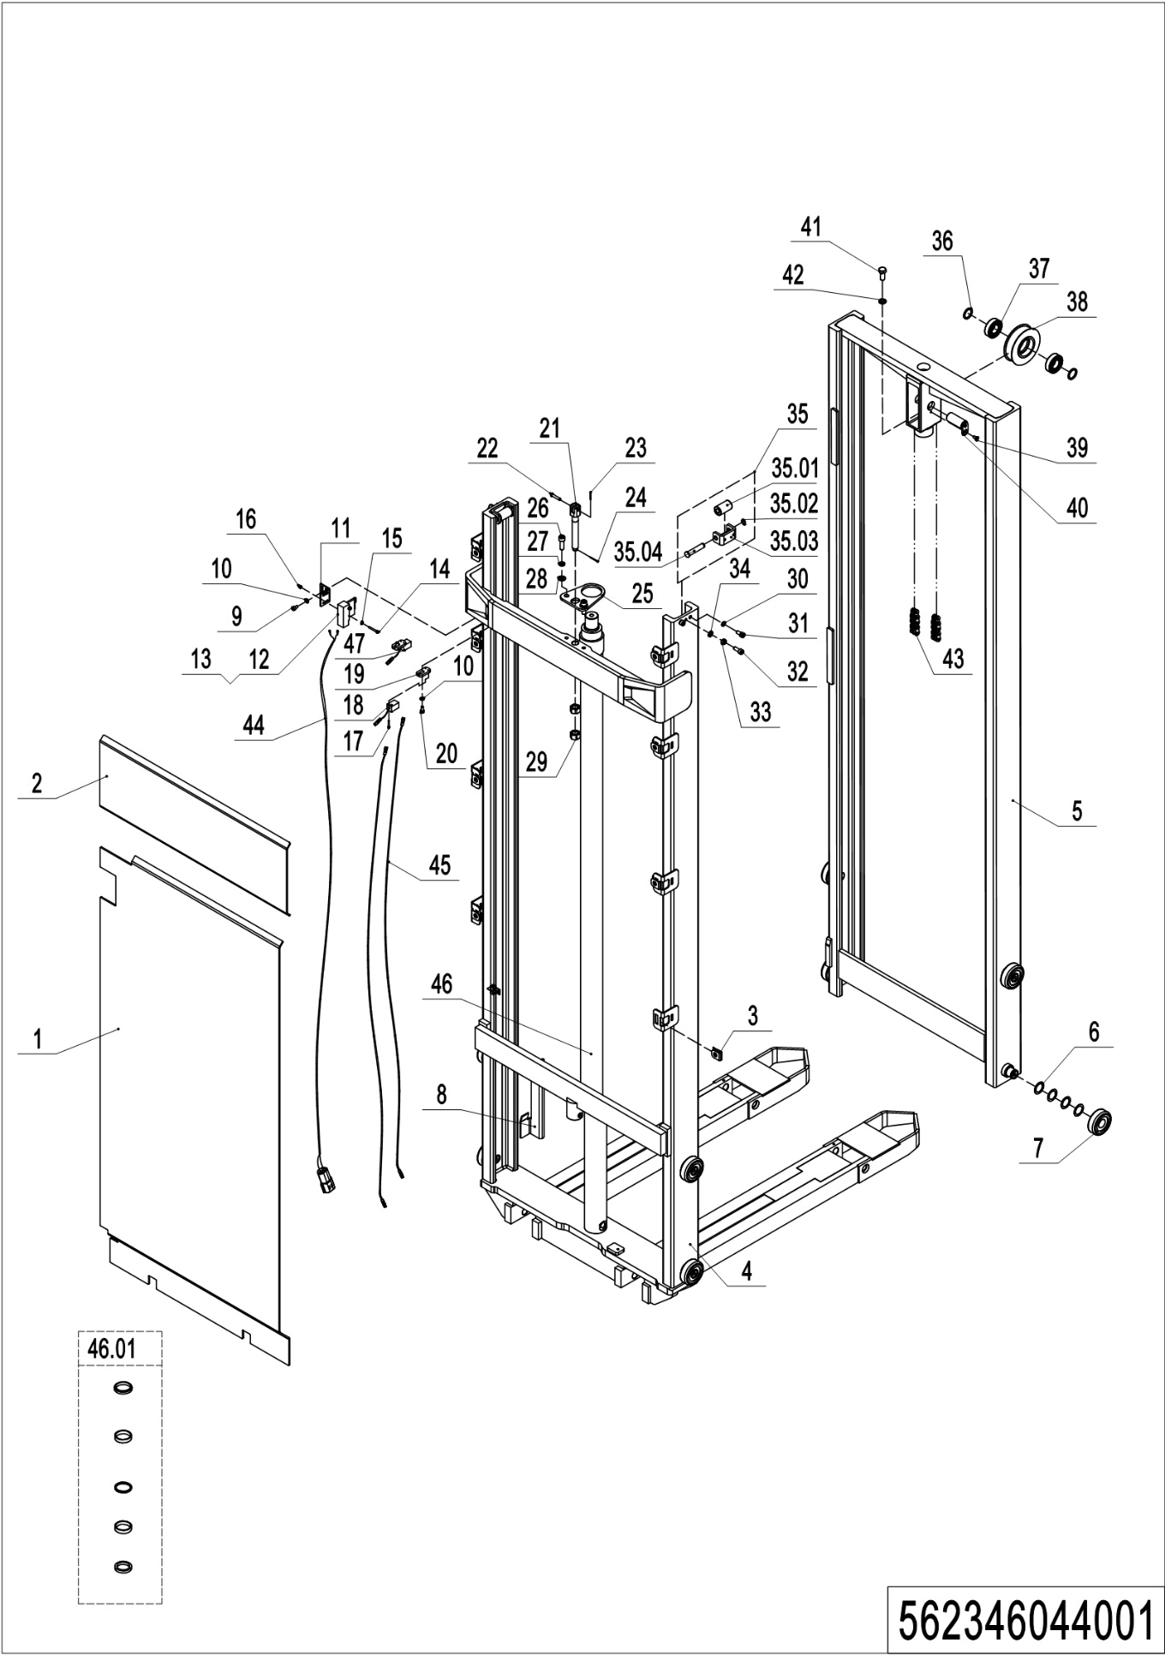
01 Two stage mast (562346044001) continuation
No. | Item Code | Mark | Item Description | Qty. | Substitute | Note
16 | 910300500001 | 1 | Nut | 2
17 | 910200500015 | 1 | Screw | 4
18 | 920200400030 |  | Proximity Switch | 1
19 | 562344020004 |  | Plate | 2
20 | 910200200033 | 1 | Screw | 2
21 | 206044520060 |  | Chain Anchor | 1
22 | 941100800010 | 1 | Pin | 1
23 | 910600600006 | 1 | Cotter Pin | 1
24 | 910600600019 | 1 | Cotter Pin | 1
25 | 532244020027 |  | Fixing Plate | 1
26 | 910200200077 | 1 | Screw | 2
27 | 910400500007 | 1 | Spring Washer | 2
28 | 910400100007 | 1 | Flat Washer | 2
29 | 910300200008 |  | Nut | 2
30 | 910400500006 | 1 | Spring Washer | 4
31 | 910200200055 | 1 | Screw | 4
32 | 910200200057 | 1 | Screw | 2
33 | 910300100006 | 1 | Nut | 2
34 | 910400100006 | 1 | Flat Washer | 2
35 | 400244010002 |  | Roller | 2
35.01 | 401744020000 |  | Roller | 2
35.02 | 910401300003 | 1 | Circlip | 2
35.03 | 532021520075 |  | Wheel Mount | 2
35.04 | 401744020001 |  | Pin | 2
36 | 940600500006 |  | Washer | 2
37 | 910700200020 |  | Bearing | 2
38 | 940200400002 |  | Sprocket | 1
39 | 910200400016 | 1 | Screw | 1
40 | 533243510005 |  | Pin | 1

01 Two stage mast (562346044001) continuation
01 Two stage mast (562346044001) continuation
No. | Item Code | Mark | Item Description | Qty. | Substitute | Note
41 | 910100300049 | 1 | Bolt | 1
42 | 910400500008 | 1 | Spring Washer | 1
43 | 532244010020 |  | Chain | 1 |  | 2600
 | 532244010007 |  | Chain | 1 |  | 2900
 | 532244010014 |  | Chain | 1 |  | 3200
 | 206044510103 |  | Chain | 1 |  | 3600
44 | 532233010002 |  | Wire Harness | 1
45 | 921500100077 |  | Cable | 2
46 | 532244010016 |  | Cylinder | 1 |  | 2600
 | 532244010001 |  | Cylinder | 1 |  | 2900
 | 532244010009 |  | Cylinder | 1 |  | 3200
 | 532244010004 |  | Cylinder | 1 |  | 3600
46.01 | 532298510002 |  | Seal Kit | 1
47 | 920200400010 |  | Proximity Switch | 1

02 Single mast (562346043001)
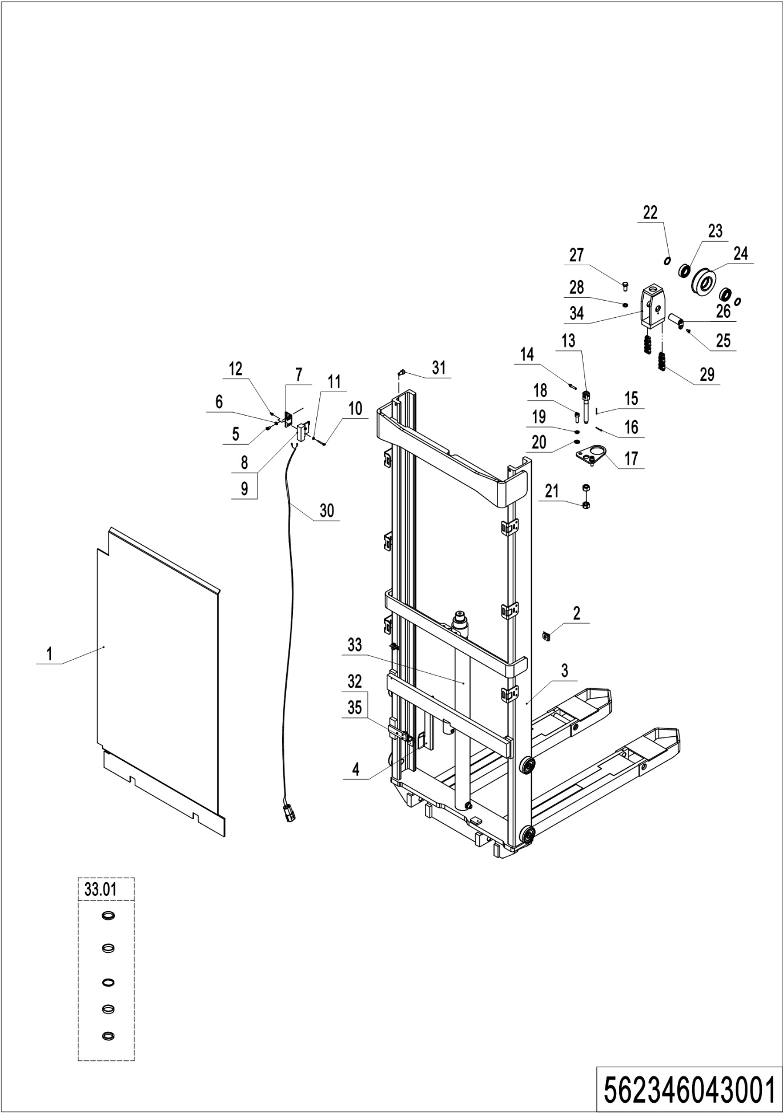
02 Single mast (562346043001)
No. | Item Code | Mark | Item Description | Qty. | Substitute | Note
1 | 562343020005 |  | Guard Plate | 1 |  | 1600
 | 562343020007 |  | Guard Plate | 1 |  | 2000
2 | 940400300001 |  | Spring Buckle | 8
3 | 562343010001 | 2 | Outer Mast (1600,570x1150) | 1 |  | 1600,570x1150
 | 562343010002 | 2 | Outer Mast (1600,685x1150) | 1 |  | 1600,685x1150
 | 562343010003 | 2 | Outer Mast (2000,570x1150) | 1 |  | 2000,570x1150
 | 562343010004 | 2 | Outer Mast (2000,685x1150) | 1 |  | 2000,685x1150
4 | 562344020005 |  | Plate | 1
5 | 910200200032 | 1 | Screw | 2
6 | 910400100005 | 1 | Flat Washer | 2
7 | 532244020012 |  | Mounting Plate | 1
8 | 920200300003 |  | Microswitch | 1
9 | 920200300007 |  | Protective Cover | 1
10 | 910200500028 | 1 | Screw | 2
11 | 910400100003 | 1 | Flat Washer | 2
12 | 910300500001 | 1 | Nut | 2
13 | 206044520060 |  | Chain Anchor | 1
14 | 941100800010 | 1 | Pin | 1
15 | 910600600006 | 1 | Cotter Pin | 1
16 | 910600600019 | 1 | Cotter Pin | 1
17 | 532243020022 |  | Plate | 1
18 | 910200200077 | 1 | Screw | 2
19 | 910400500007 | 1 | Spring Washer | 2
20 | 910400100007 | 1 | Flat Washer | 2
21 | 910300200008 | 1 | Nut | 2
22 | 940600500006 |  | Washer | 2
23 | 910700200020 |  | Bearing | 2
24 | 940200400002 |  | Sprocket | 1
25 | 910200400016 | 1 | Screw | 1

02 Single mast (562346043001) continuation
02 Single mast (562346043001) continuation
No. | Item Code | Mark | Item Description | Qty. | Substitute | Note
26 | 533243510005 |  | Pin | 1
27 | 910100300049 | 1 | Bolt | 1
28 | 910400500008 | 1 | Spring Washer | 1
29 | 532344510009 |  | Chain | 1 |  | 1600
 | 532344510004 |  | Chain | 1 |  | 2000
30 | 532233010002 |  | Wire Harness | 1
31 | 941100100005 |  | Screw | 2
32 | 920200400030 |  | Proximity Switch | 1
33 | 532243010001 |  | Cylinder | 1 |  | 1600
 | 532243010004 |  | Cylinder | 1 |  | 2000
33.01 | 532298510002 |  | Seal Kit | 1
34 | 532243010002 |  | Yoke | 1
35 | 562343020006 |  | Plate | 1

03 Pull rod assembly (562346044002)
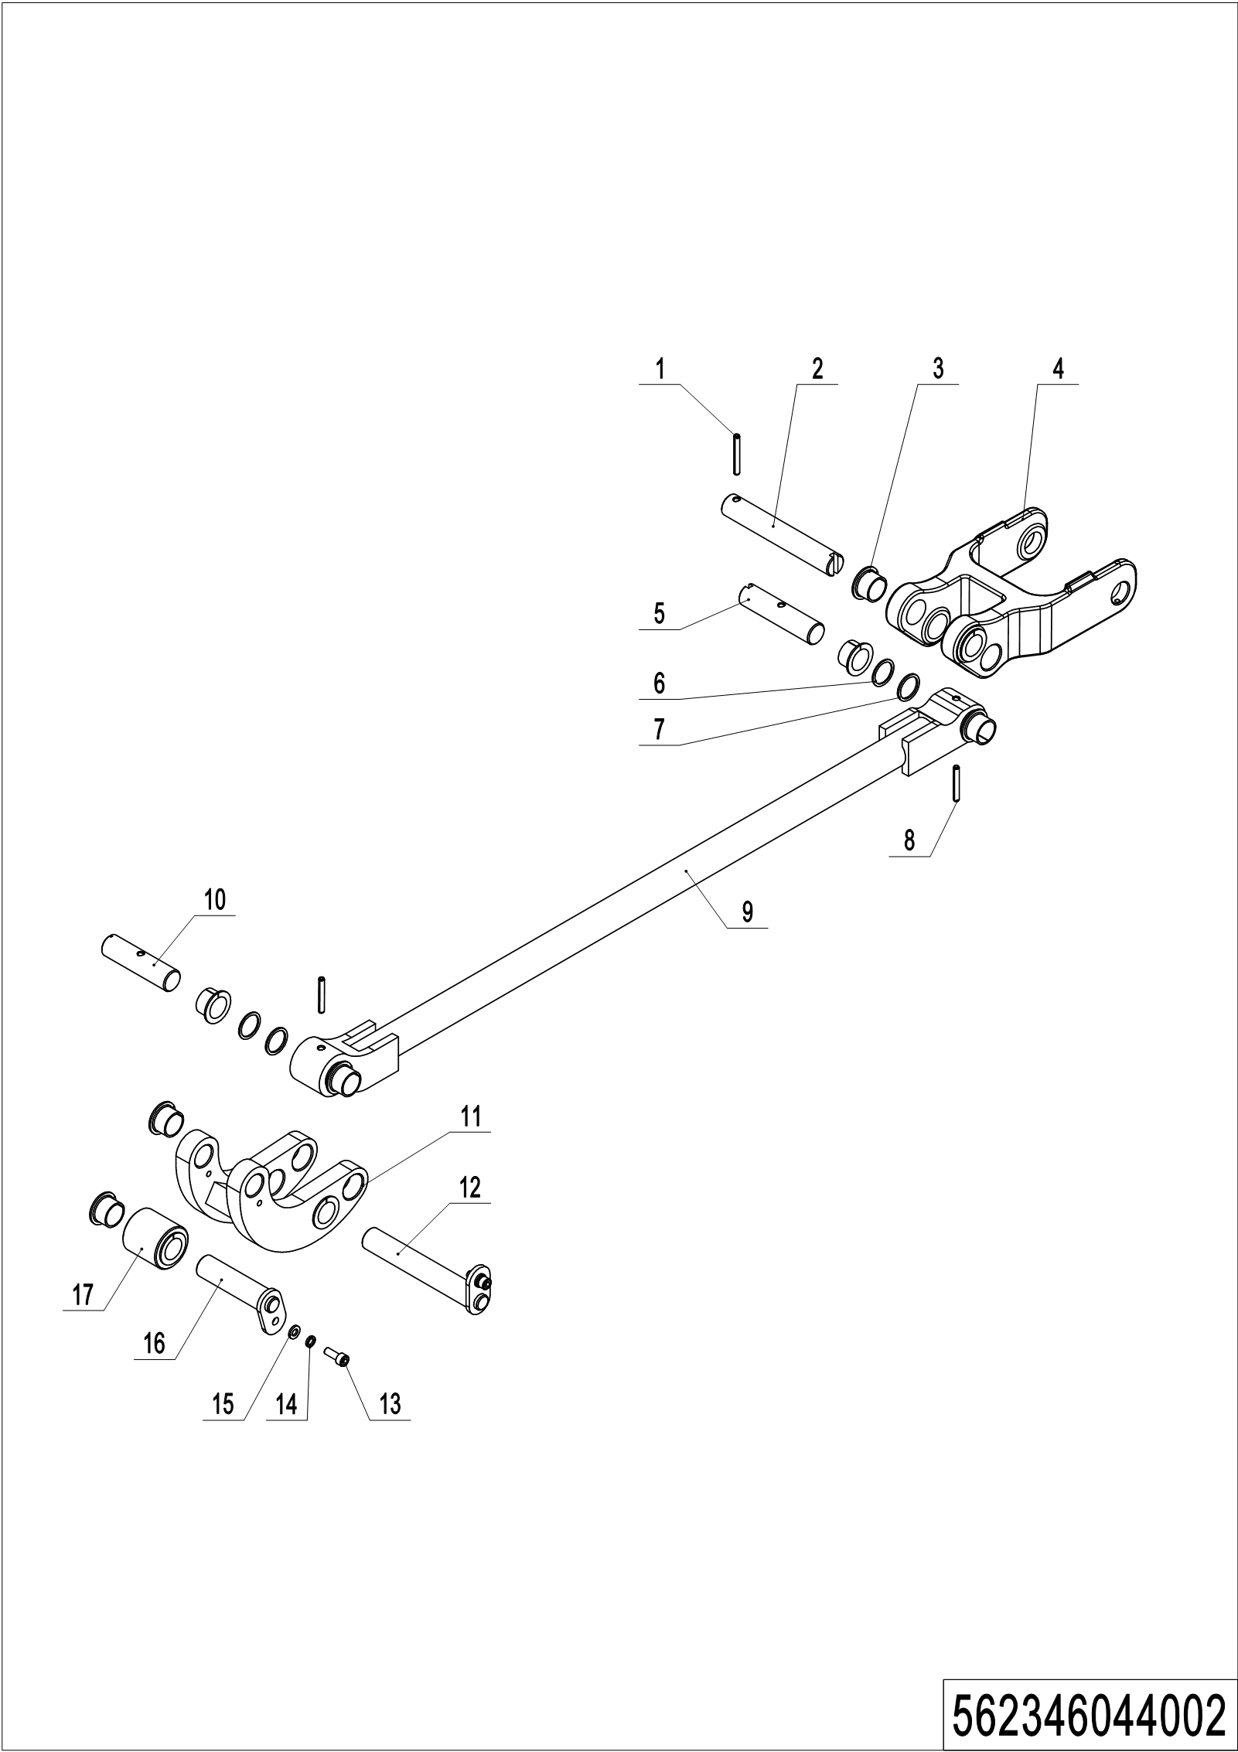
03 Pull rod assembly (562346044002)
No. | Item Code | Mark | Item Description | Qty. | Substitute | Note
1 | 910600400028 |  | Spring Pin | 2
2 | 562038520025 |  | Pin | 2
3 | 940500200041 |  | Bushing | 20
4 | 562344020001 |  | Frame of roller | 2
5 | 562038520024 |  | Axle | 2
6 | 940600500013 |  | Washer | 8
7 | 940600500014 |  | Washer | 8
8 | 910600400027 |  | Spring Pin | 2
9 | 562344010004 |  | Pull rod welding | 2
10 | 562038520028 |  | Axle | 2
11 | 562344010003 |  | Linking plate welding | 2
12 | 562038510003 |  | Pin | 2
13 | 910200200035 |  | Screw | 4
14 | 910400500005 |  | Spring Washer | 4
15 | 910400100005 |  | Flat Washer | 4
16 | 562038510005 |  | Pin | 2
17 | 562344020006 |  | Roller | 2

Chapter 6: Electrical parts and wire harness

01 Wire harness (562346033001)
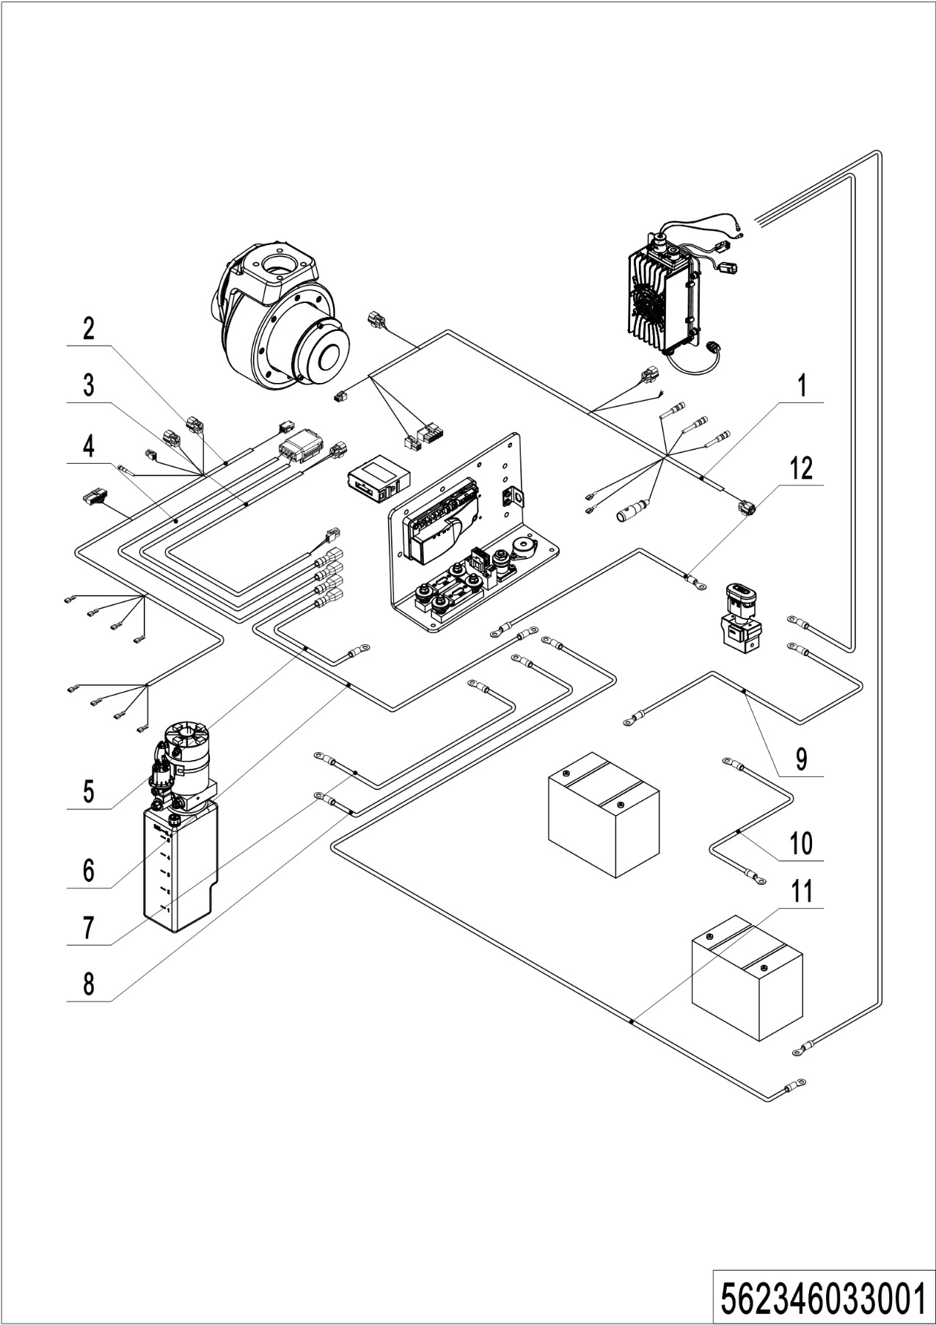
01 Wire harness (562346033001)
No. | Item Code | Mark | Item Description | Qty. | Substitute | Note
1 | 562333010000 |  | Wire Harness | 1
2 | 562333010002 |  | Wire Harness | 1
3 | 532233010003 |  | Wire Harness | 1
4 | 532233010004 |  | Wire Harness | 1
5 | 532233010005 |  | Cables | 1
6 | 532233010006 |  | Cables | 1
7 | 532233010007 |  | Cable | 1
8 | 532233010009 |  | Cable | 1
9 | 532233010010 |  | Cable | 1 |  | 85AH
 | 532233010013 |  | Cable | 1 |  | 106AH
10 | 532233010011 |  | Cable | 1 |  | 85AH
 | 532233010014 |  | Cable | 1 |  | 106AH
11 | 532233010012 |  | Cable | 1 |  | 85AH
 | 532233010015 |  | Cable | 1 |  | 106AH
12 | 532233010016 |  | Cable | 1

02 Wire harness (lithium battery) (562346033002)
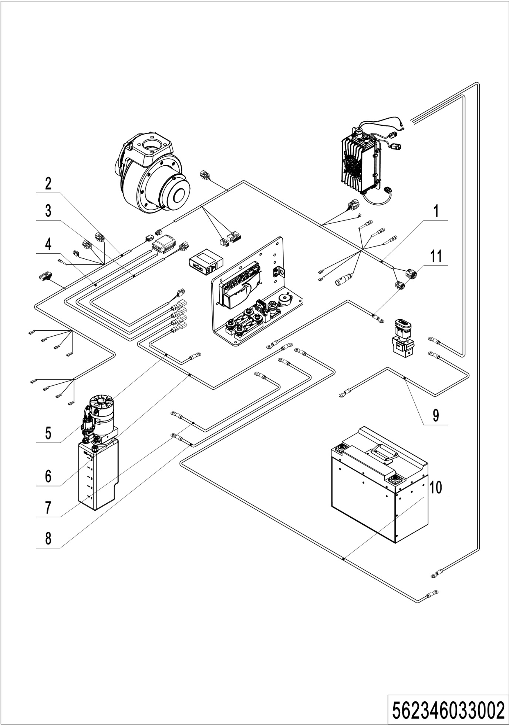
02 Wire harness (lithium battery) (562346033002)
No. | Item Code | Mark | Item Description | Qty. | Substitute | Note
1 | 562333010001 |  | Wire Harness | 1
2 | 562333010002 |  | Wire Harness | 1
3 | 532233010003 |  | Wire Harness | 1
4 | 532233010004 |  | Wire Harness | 1
5 | 532233010005 |  | Cables | 1
6 | 532233010006 |  | Cables | 1
7 | 532233010007 |  | Cable | 1
8 | 532233010009 |  | Cable | 1
9 | 532233010020 |  | Cable | 1
10 | 532233010021 |  | Cable | 1
11 | 532233010016 |  | Cable | 1

03 Electrical control unit (562346033003)
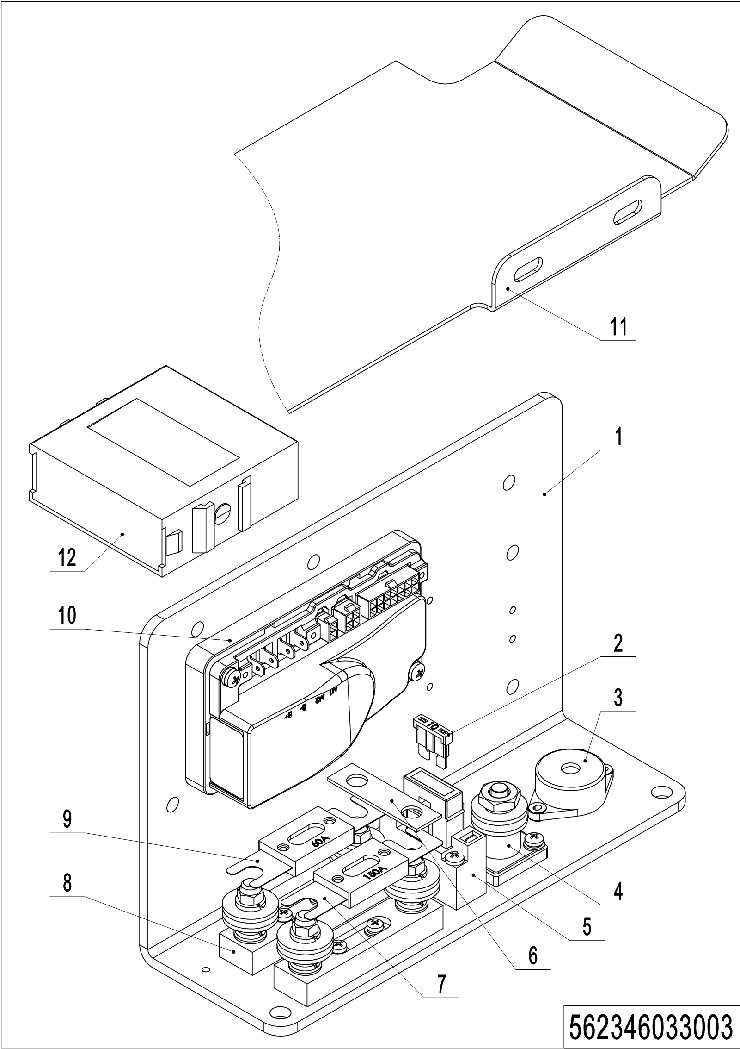
03 Electrical control unit (562346033003)
No. | Item Code | Mark | Item Description | Qty. | Substitute | Note
1 | 532233020001 |  | Mounting Plate | 1
2 | 920100200002 |  | Fuse | 1
3 | 920500100007 |  | Horn | 1
4 | 920100400001 |  | Fuse Holder | 1
5 | 920100400006 |  | Fuse Holder | 1
6 | 505633020003 |  | Copper Busbar | 1
7 | 920100100007 |  | Fuse | 1
8 | 920100400002 |  | Fuse Holder | 2
9 | 920100100003 |  | Fuse | 1
10 | 921400100081 |  | Controller | 1
11 | 532221520027 |  | Baffle | 1
12 | 921200100016 |  | Module CAN Communication | 1

04 Charger (532246036501)
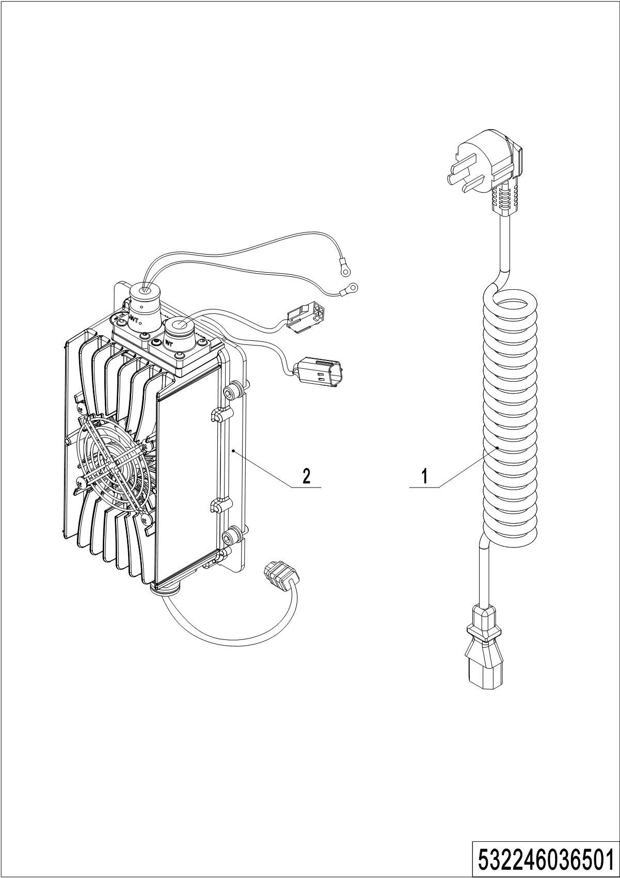
04 Charger (532246036501)
No. | Item Code | Mark | Item Description | Qty. | Substitute | Note
1 | 921500200008 |  | Spring Cable（Asia） | 1
 | 921500200005 |  | Spring Cable(EU) | 1
 | 921500200003 |  | Spring Cable(AUS) | 1
 | 921500200004 |  | Spring Cable(ENG) | 1
 | 921500200002 |  | Spring Cable(USA) | 1
 | 921500200037 |  | Spring Cable(ARG) | 1
 | 921500200006 |  | Spring Cable(ITY) | 1
 | 921500200007 |  | Spring Cable(SWD) | 1
 | 921500200029 |  | Spring Cable(ISR) | 1
 | 921500200061 |  | Spring Cable(BRA) | 1
2 | 921000100055 |  | Charger24V12V | 1 |  | Lead-acid battery
 | 921000100052 |  | Charger 24V25A | 1 |  | Lithium battery

Chapter 7: Special equipment

01 Load backrest (532246040501)
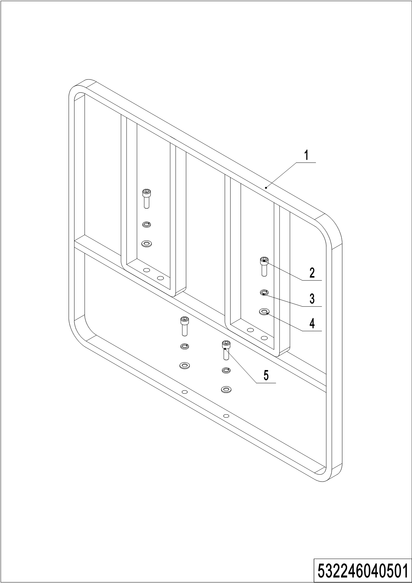
01 Load backrest （532246040501）
No. | Item Code | Mark | Item Description | Qty. | Substitute | Note
1 | 532640510001 | 2 | Load Backrest | 1
2 | 910200200077 | 1 | Screw | 2
3 | 910400500007 | 1 | Spring Washer | 4
4 | 910400100007 | 1 | Flat Washer | 4
5 | 910200200076 | 1 | Screw | 2

02 Load backrest (Single mast) (532246040502)
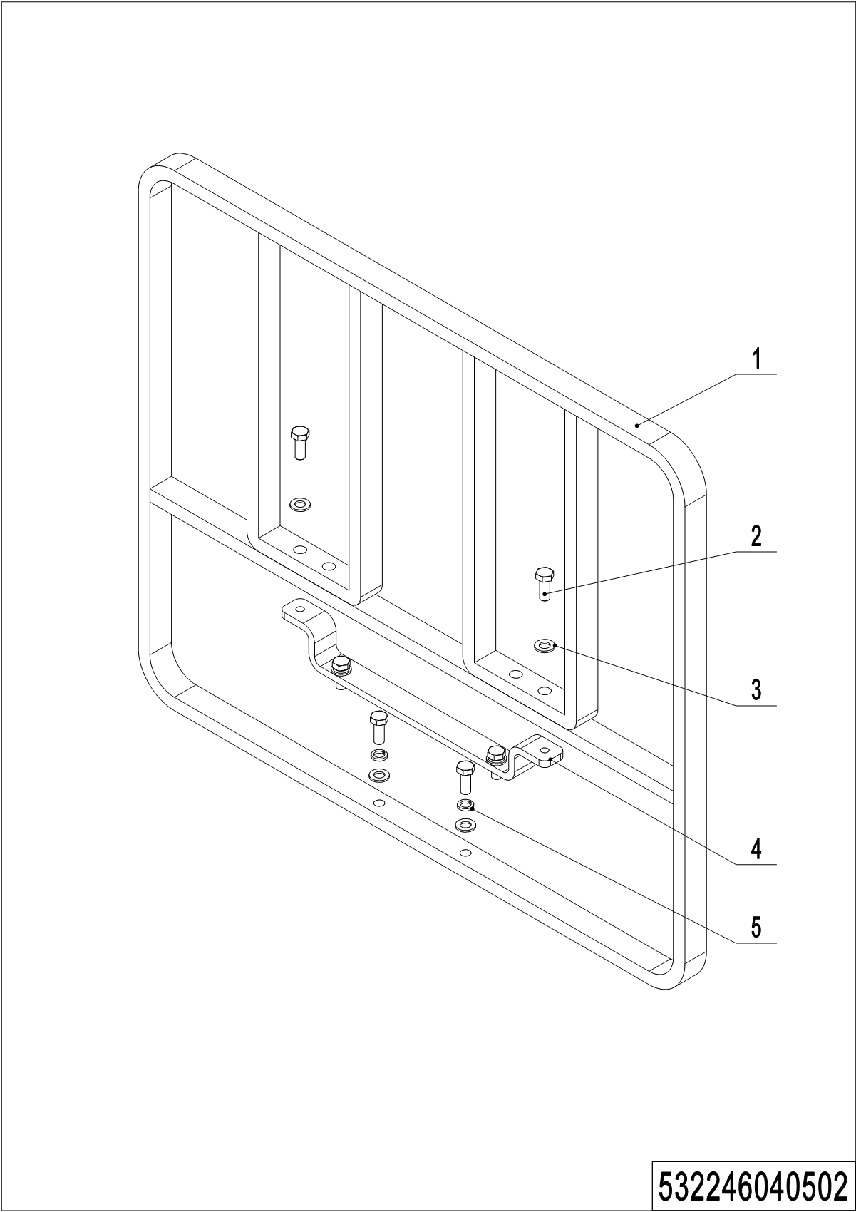
02 Load backrest (Single mast) (532246040502)
No. | Item Code | Mark | Item Description | Qty. | Substitute | Note
1 | 532640510001 | 2 | Load Backrest | 1
2 | 910100300036 | 1 | Bolt | 6
3 | 910400100007 | 1 | Flat Washer | 6
4 | 532240520001 |  | Division Plate | 1
5 | 910400500007 | 1 | Spring Washer | 4

Chapter 8: Others

01 Labels and decals (EU) (562346047001)
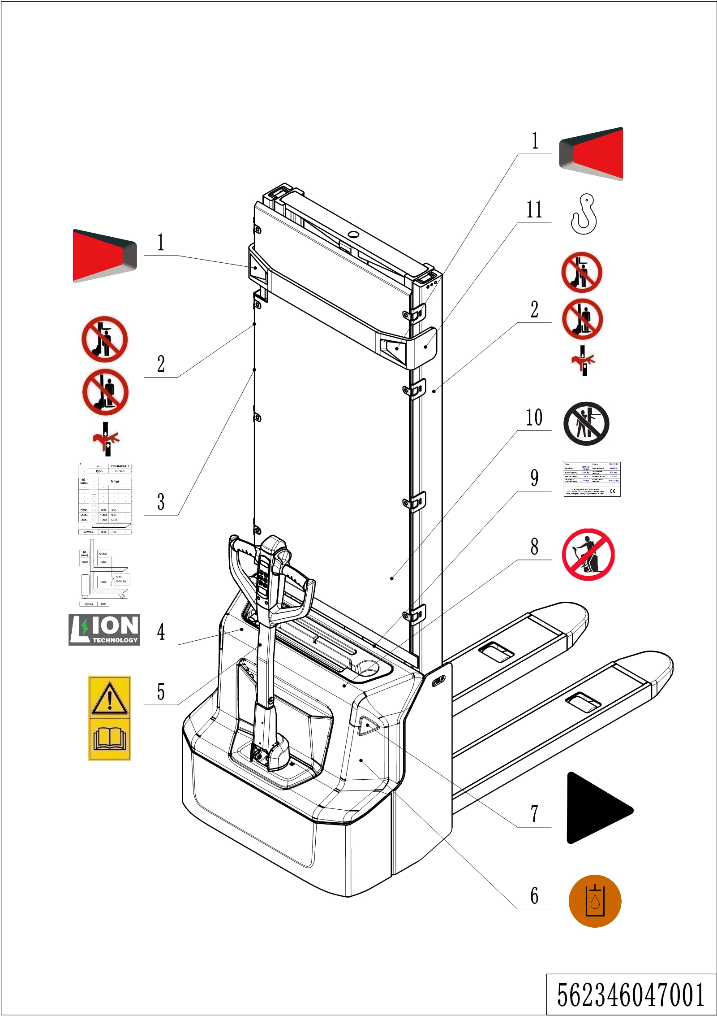
01 Labels and decals (EU) (562346047001)
No. | Item Code | Mark | Item Description | Qty. | Substitute | Note
1 | 532247020007 |  | Label | 1
2 | 941200100004 |  | Label | 2
3 | 562347520001 |  | Load Capacity Diagram | 1
 | 562347520003 |  | Load Capacity Diagram | 1
4 | 532247020002 |  | Label | 1 |  | Lithium battery
5 | 941200300002 |  | Label | 1
6 | 941200300003 |  | Label | 1 |  | Inside
7 | 532247020000 |  | Label | 2
8 | 941200100003 |  | Label | 1
9 | 562347520002 |  | Truck data plate | 1
10 | 941200100006 |  | Label | 1
11 | 941200300001 |  | Label | 2

02 Labels and decals (USA) (562346047002)
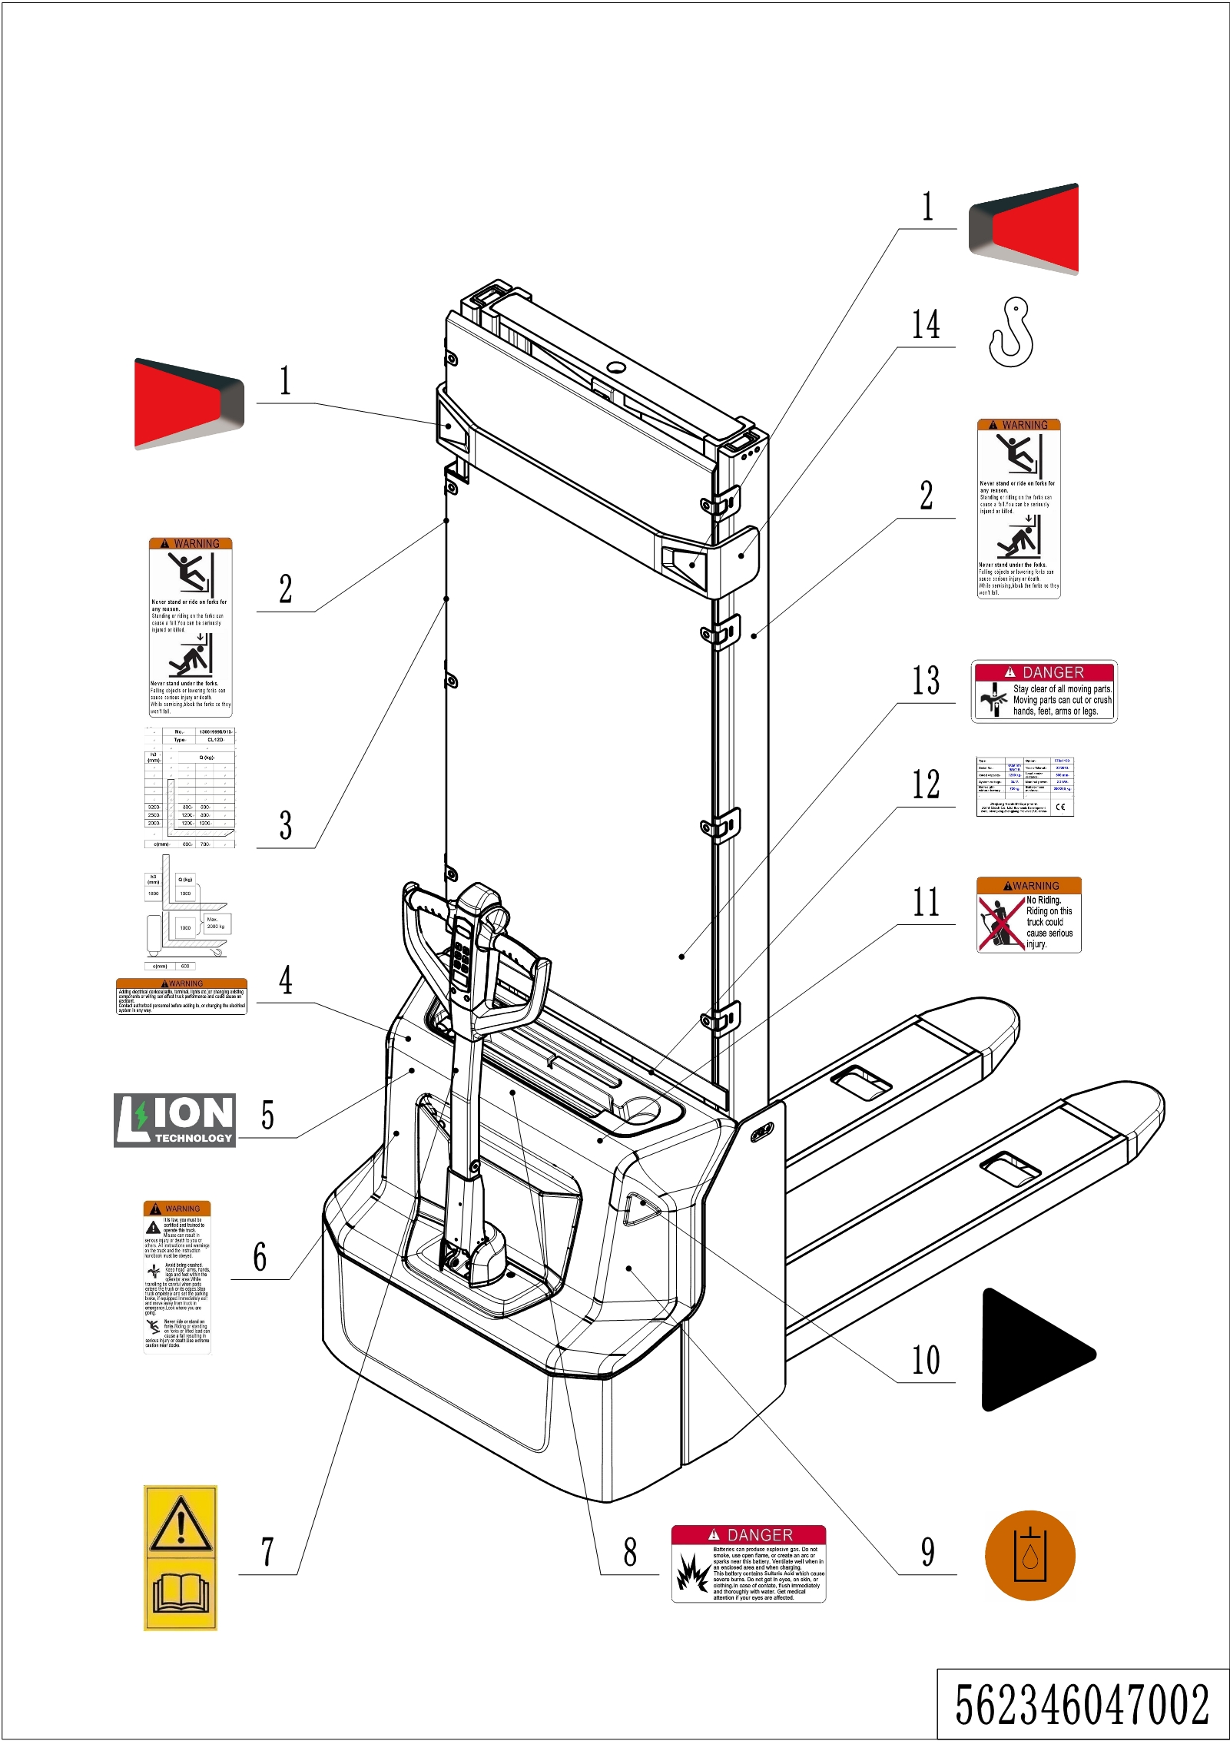
02 Labels and decals (USA) (562346047002)
No. | Item Code | Mark | Item Description | Qty. | Substitute | Note
1 | 532247020007 |  | Label | 1
2 | 941200100016 |  | Label | 2
3 | 562347520001 |  | Load Capacity Diagram | 1
 | 562347520003 |  | Load Capacity Diagram | 1
4 | 941200100010 |  | Label | 1
5 | 532247020002 |  | Label | 1 |  | Lithium battery
6 | 941200100009 |  | Label | 1
7 | 941200300002 |  | Label | 1
8 | 941200100013 |  | Label | 1
9 | 941200300003 |  | Label | 1 |  | Inside
10 | 532247020000 |  | Label | 2
11 | 941200100011 |  | Label | 1
12 | 562347520002 |  | Truck data plate | 1
13 | 941200100014 |  | Label | 1
14 | 941200300001 |  | Label | 2

Appendix
01 Electrical circuit diagram (lead-acid battery) (562346045501)
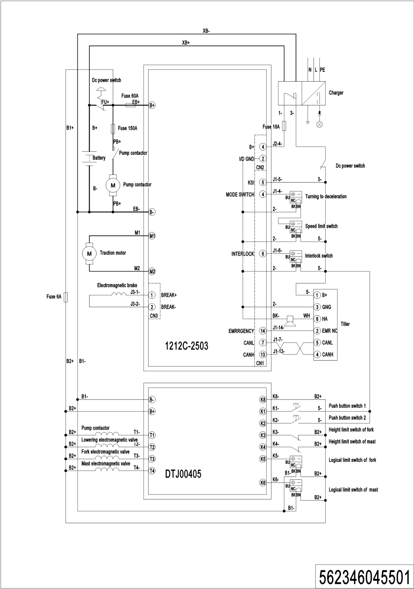
02 Electrical circuit diagram (Lithium battery) (562346045502)
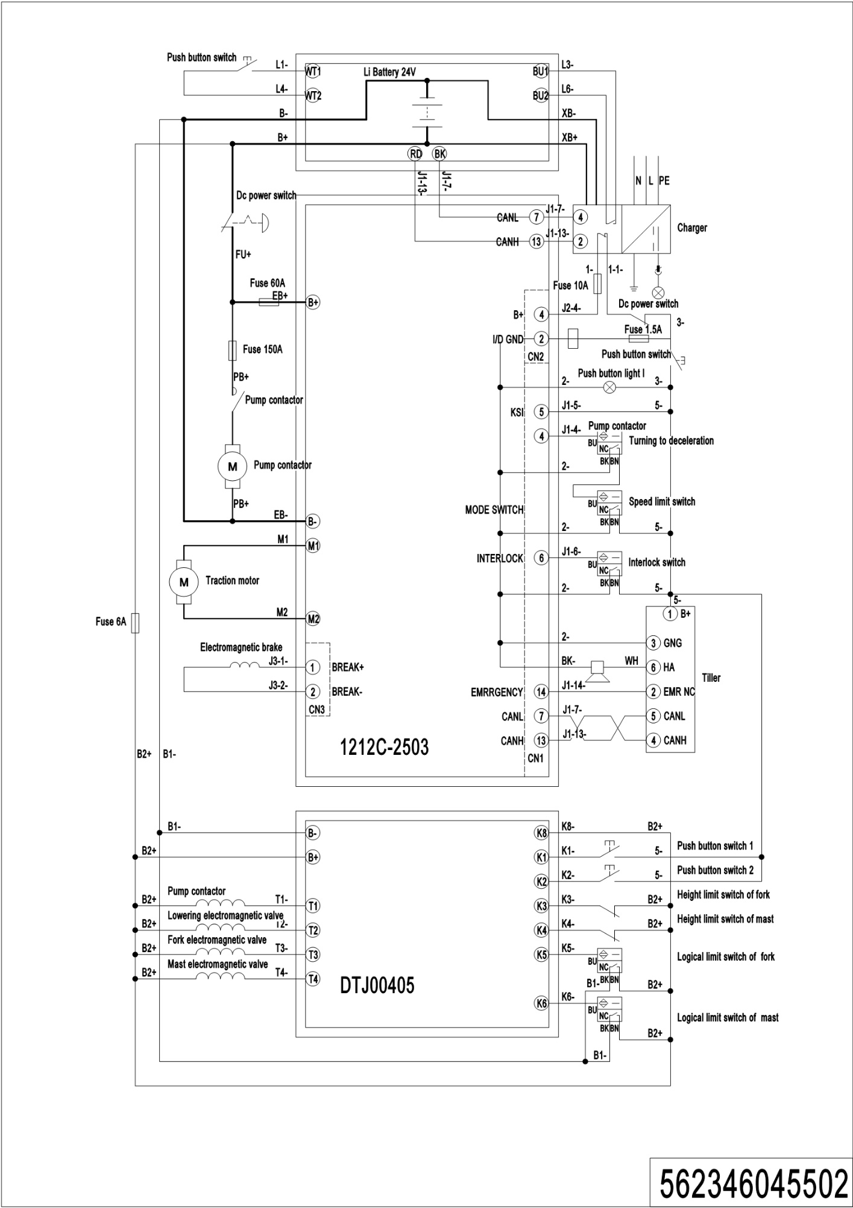
03 Hydraulic circuit diagram (562346045503)
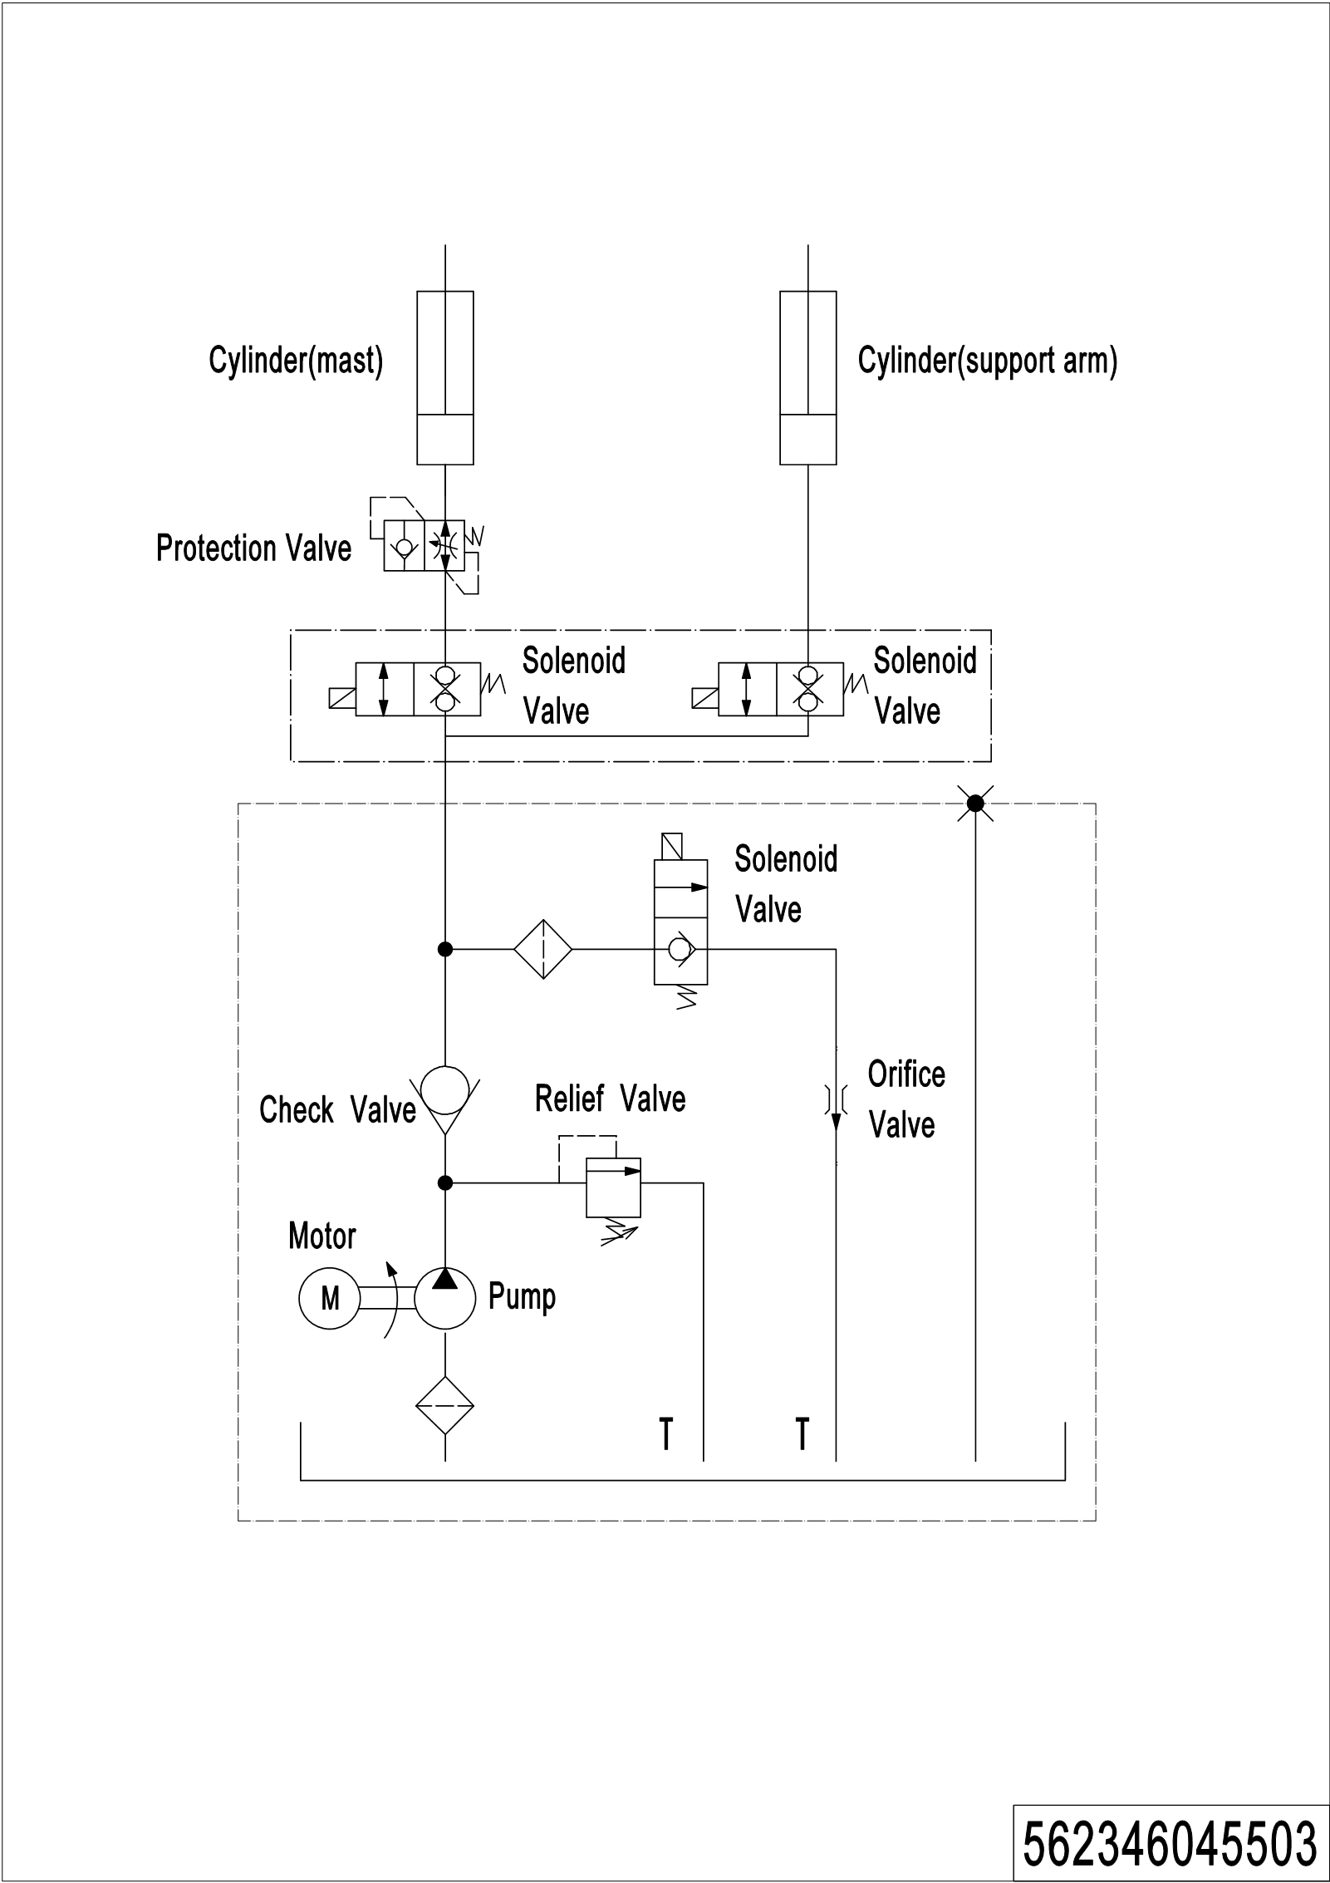
04 Easy worn parts list
No. | Item Code | Item Description | Qty. | Chapter/ Section/ Number
1 | 910700200019 | Bearing | 4 | Chapter 4/03/1.01
 | 910700200019 | Bearing | 2 | Chapter 4/04/10.02
2 | 940300300011 | WheelΦ84x93 | 2 | Chapter 4/03/1.02
3 | 532298510003 | Wheel | 2 | Chapter 4/03/1
4 | 940300300030 | WheelΦ100x50 | 1 | Chapter 4/04/10.01
5 | 910700600001 | Bearing | 1 | Chapter 4/04/15
6 | 910700700011 | Bearing | 1 | Chapter 4/04/8
7 | 532298510004 | Caster Assembly | 1 | Chapter 4/04/10
8 | 532211020003 | Gas Spring | 1 | Chapter 4/01/10.3
9 | 940500200001 | Bushing | 2 | Chapter 4/01/6
10 | 532298510002 | Seal Kit | 1 | Chapter 5/01/46.01 Chapter 5/02/33.01
11 | 910700200020 | Bearing | 2 | Chapter 5/01/37 Chapter 5/02/23
12 | 920100100003 | Fuse | 1 | Chapter 6/03/9
13 | 920100100007 | Fuse | 1 | Chapter 6/03/7
14 | 920100200002 | Fuse | 1 | Chapter 6/03/2

